His Excellency the vice Rector of Academic Affairs Accompanied with a Team of the University's Councilors, Visited the Community College.
His Excellency The vice Rector of Academic Affairs Prof. Mohammad bin Othman Al-Rukban accompanied with a team of the university's councilors, visited the Community College where they were greeted by His Excellency the college’s Dean Dr. Abdullah Al-Dahash along with a group of the colleges’ administrative leaders who welcomed him and his companions as well. The visit was commenced by a fatherly meeting between Prof. Mohammad Al-Rukban and the college’s students in which His Excellency the vice Rector listened closely to the students’ comments, aspirations and what can improve their academic and skillfulness attainment. Also, the university councilors sat with the heads and members of the college’s units and committees to study and revise their work mechanisms and their recommendations regarding these issues. Furthermore, the vice Recto’s visit included a meeting with the faculty members to discuss with them some academic concepts of the Community College’s vision of the future in the light of the university’s leadership and His Highness The Rector Dr. Khaled bin Saad Al-Migren enthusiasm for activation of the college’s development. A discussion of the faculty members’ suggestions on how to develop the faculty members’ skills took place. The visit came to an end, with a meeting between His Excellency and the team of the university councilors with the college’s leadership to discuss the visit’s outcomes and how to benefit at most from the comments made by the Vice Dean Office’s team through the visit’s schedule.

سعادة وكيل الجامعة للشؤون التعليمية في لقاء مع أعضاء هيئة التدريس بالكلية
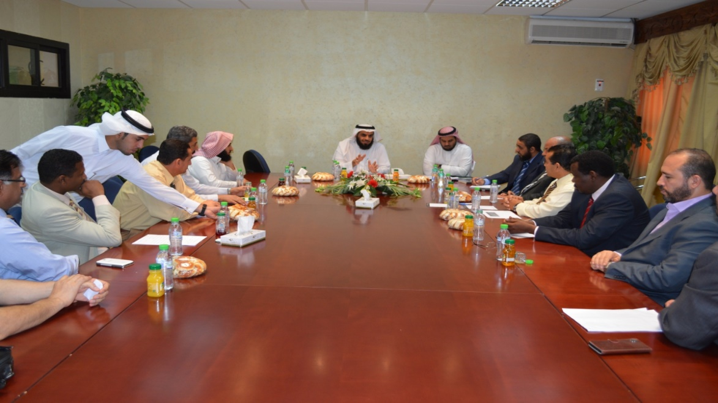

سعادة وكيل الجامعة للشؤون التعليمية في لقاء خاص مع طلاب الكلية
