Dr. Abdullah bin Ahmed Al Dahesh participated in a research paper at the International Conference

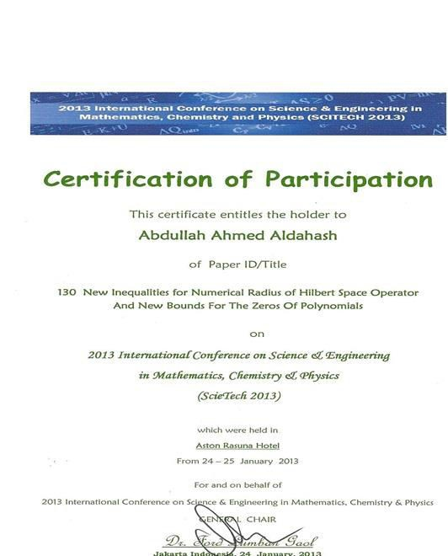
of Science and Mathematics Engineering, Chemistry and Physics in Jakarta

