**Workshop-Quality and Accreditation Standards in Academic Advising**

**Under the patronage of His Excellency (HE) the Dean Dr. Abdullah bin Khalifa Suwaiket, the Quality Center organized  a workshop entitled-Quality and Accreditation Standards in Academic Advising- on Sunday, 23/03/1434 AH.**

**The workshop started with a speech by His Excellency Vice Dean of Studies and Development Dr. Rashid bin Hamoud Al-Thunayan who talked about academic advising and its importance to the students and highlighted the significance of education and guidance  for the university student.**

**Dr. Abdullah bin Khalifa  Suwaiket, under whose patronage the event took place,  emphasized that the college needed to hold such workshops, given their importance  to students-male and female alike- because they are the target group for academic guidance, since guidance is one of the most significant  colleges services which can benefit students.**

**Then, the workshop started with Prof. Hamzah M , Ayasrah who covered several topics of the workshop, namely  
 .The concept of Academic Advising  
 .Functions of the Academic Advisor  
 .Academic counseling skills  
- Targeted programs for the application of academic advising at the College of Education**

**Dr. Abdulhakim Radwan, Head of the Center for Quality and the Quality Unit, in his turn, elaborated on a number of themes, such as  
. Goals of Academic Advising at the College of Education  
. International experiences in the quality of Academic Advising**

**.The College of Education Students’ views on the quality of Academic Advising**

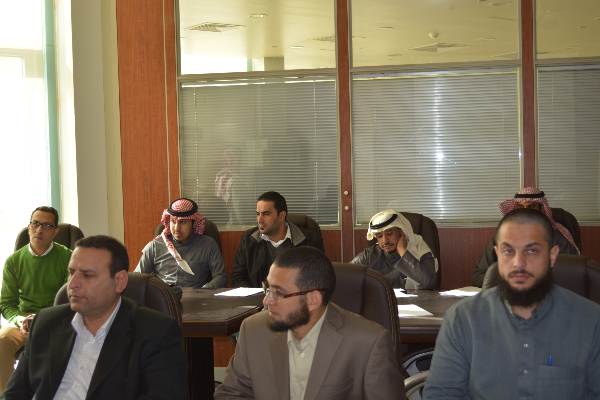

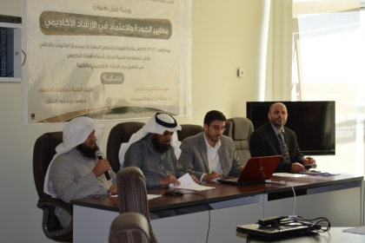

**http://www.mu.edu.sa/sites/default/files/mu_standardDSC_0999399.JPG**

