**Geotextiles**

**dr.Ibrahim .g.,e.**

The expression “geotextiles" is used to describe textile fabrics or other textile products which are used also in combination with textiles or non-textile elements in the diverse sectors of the construction industry, usually in conjunction with soil, rock, water or any other geotechnical materials for improving the engineering performance of the engineering works. Geotextiles are defined by the American Society for Testing Materials (ASTM) D 35 as “ any permeable textile used with geotechnical materials as an integral part of a man-made project , structure or system”.Geotextiles are a member of a larger family called geo-synthetics, other members are geogrids, geonets, geomembranes, and geocomposites. Geotextiles are the largest group of geosynthetics in terms of volume, they are used in geotechnical engineering, heavy construction, building and pavement construction, hydrogeology and environmental engineering.

[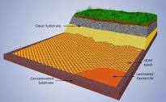](http://www.google.com.sa/imgres?start=90&hl=ar&sa=X&biw=1366&bih=647&tbm=isch&prmd=imvns&tbnid=8TCCCd1d-JFX9M:&imgrefurl=http://www.sigmahellas.gr/index.php?lang=2&thecatid=4&thesubcatid=428&thesubsubcatid=434&docid=AxJtXSHsk4rdKM&imgurl=http://www.sigmahellas.gr/themedia/Image/Geotextile%20Mesh%20for%20contaminated%20land.jpg&w=500&h=308&ei=A_t9T7DrM8fDswaaw-mlDg&zoom=1) 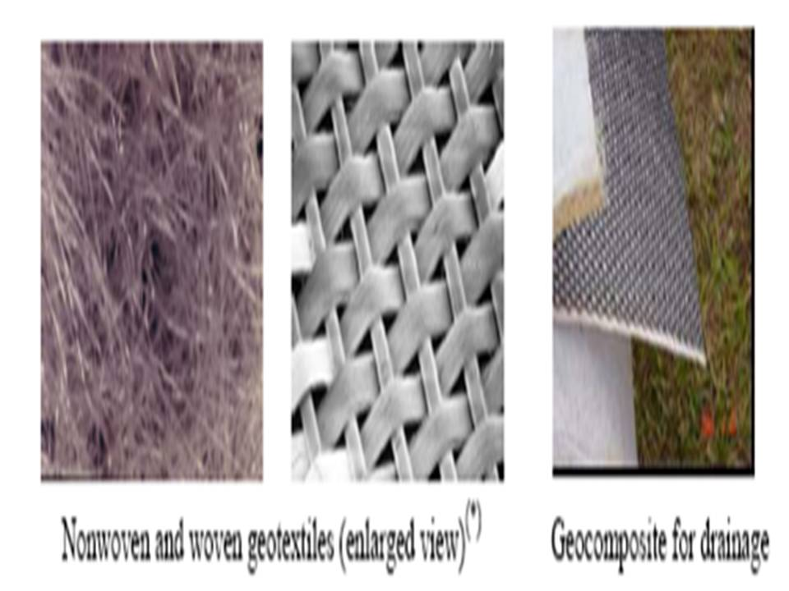

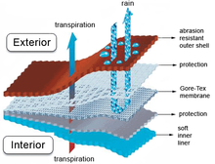

**Geotextile Functions**

Geotextiles and related products may be used in a wide range of applications where they may be required to perform one, or a combination, of design functions. Different functions, and different operational environments, will make different demands on the geotextile.

In general the two broad requirements of a geotextile are that it must be robust enough to survive short term environments as well as maintaining adequate properties in the long term to fulfill the required design function .

In civil engineering structures a geotextile performs mechanical functions such as separation and reinforcement and hydraulic functions such as drainage and filtration either separately or simultaneously. Beside these functions there are two other functions ,these are water proofing and protection.

[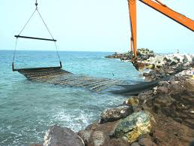](http://www.google.com.sa/imgres?hl=ar&sa=X&biw=1366&bih=647&tbm=isch&prmd=imvns&tbnid=UnIswc9zumkKqM:&imgrefurl=http://www.capitalsignal.com/GALLERY%20FAW/Geotextile%20fabric%20SABA.htm&docid=ky3kD4pWkE1sOM&imgurl=http://www.capitalsignal.com/GALLERY%20FAW/placing-of-geotextile-fabri.jpg&w=612&h=459&ei=-vp9T__rNoXVsga3sMWSDg&zoom=1)[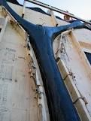](http://www.google.com.sa/imgres?start=186&hl=ar&sa=X&biw=1366&bih=647&tbm=isch&prmd=imvns&tbnid=e93_4RbCkuABHM:&imgrefurl=http://www.umanitoba.ca/cast_building/research/fabric_formwork/&docid=1dquRx1zUWc2iM&imgurl=http://www.umanitoba.ca/cast_building/assets/images/fabric_formwork/Branching_column_formed_in_a_geotextile_form-liner.jpg&w=338&h=450&ei=DPt9T--LPIjPtAbawIz3DQ&zoom=1)

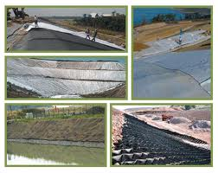

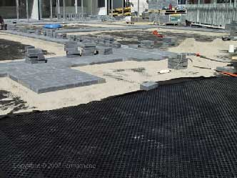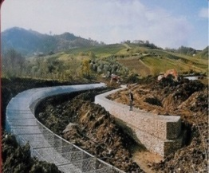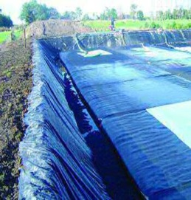

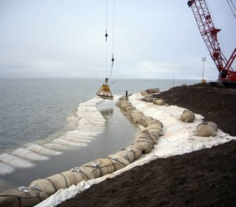

**Separation Function**

Geotextiles are used to separate two dissimilar materials such as two layers of soil with different properties . The purpose of separation is to maintain or improve the integrity and performance of both materials.. The geotextile ensure that the aggregate maintains its load-bearing ability. Without geotextile, subsoil and aggregate base intermix and load-bearing capacity are reduced .

This function is very important in all forms of roadways, railways, and parking areas , where the material used to form the base of the construction, usually some form of aggregate , is separated from the soil below.

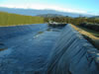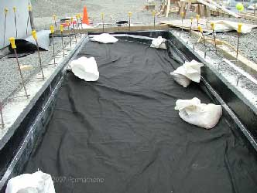

[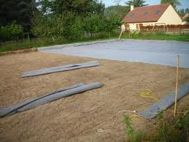](http://www.google.com.sa/imgres?start=186&hl=ar&sa=X&biw=1366&bih=647&tbm=isch&prmd=imvns&tbnid=KDg6kirFPlUHOM:&imgrefurl=http://englishclass.jp/reading/topic/Geotextile&docid=9BZIRCJAknwNbM&imgurl=http://blog.de-tocqueville.fr/public/cheval/carriere/Geotextile.jpg&w=2592&h=1944&ei=DPt9T--LPIjPtAbawIz3DQ&zoom=1)

**Reinforcement Function**

Of all the geotextile functions, reinforcement is perhaps the most diversely applied and most technically demanding. Applications vary from comparatively short term , low risk , installations such as unpaved roads ,to long term, high risk applications, such as vertical walls and bridge abutments .This function involves stabilization of soil mass by provision of tensile strength to the soil-fabric system. Geotextile of high tenacity , when placed in a soil mass, takes up some of the tensile stresses and helps distribute them more evenly.

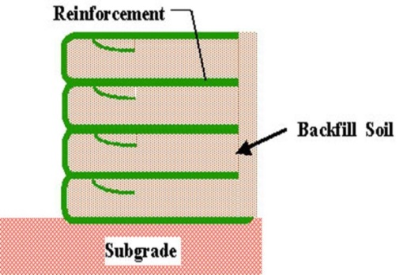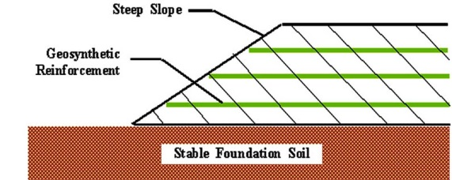

**Filtration Function**

The role of a geotextile as a filter is to permit the free flow of water from one side of the geotextile sheet to the other, without significant long-term loss of soil particles. When filtration is the primary function to be achieved two contradictory mechanisms to be achieved, adequate flow capability and upstream soil particles retention. Adequate flow requires large fabrics pores but soil particle retention requires small fabric pores. Thus, knowledge of both the flow regime and soil characteristics are essential for proper design .Typical applications areas of geotextiles for filtration are pipe underdrains, drainage for retaining walls and erosion control structures.

[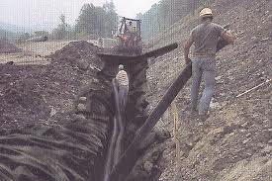](http://www.google.com.sa/imgres?start=90&hl=ar&sa=X&biw=1366&bih=647&tbm=isch&prmd=imvns&tbnid=Xf0GjIzsw0oV1M:&imgrefurl=http://www.webtecgeos.com/category.asp?csid=9&docid=rNvXtk1cvLGLgM&imgurl=http://www.webtecgeos.com/files//images/full/img2.jpg&w=450&h=300&ei=A_t9T7DrM8fDswaaw-mlDg&zoom=1) [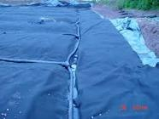](http://www.google.com.sa/imgres?start=90&hl=ar&sa=X&biw=1366&bih=647&tbm=isch&prmd=imvns&tbnid=Op9LcndfcMd3dM:&imgrefurl=http://www.jonesmcgirr.com/standoffpads.htm&docid=9WeH0btXzQwF7M&imgurl=http://www.jonesmcgirr.com/images/protection_geotextile.jpg&w=350&h=263&ei=A_t9T7DrM8fDswaaw-mlDg&zoom=1)

**Drainage Function**

Adequate drainage is essential for achieving and maintaining soil stability in embankments and in road stability etc. Graded aggregate filters have traditionally been used for drain protection, but the problem of design , cost , placement and testing of aggregate filters makes geotextiles an attractive alternative. The drainage function of a geotextile is generally associated with its ability to transmit liquid or gas in the plane of fabric without soil loss .The major difference between filtration and drainage function is the direction of flow which makes in-plane permeability critical for the drainage function. Drainage refers to planar flow as opposed to filtration which refers to flow across the geotextile.

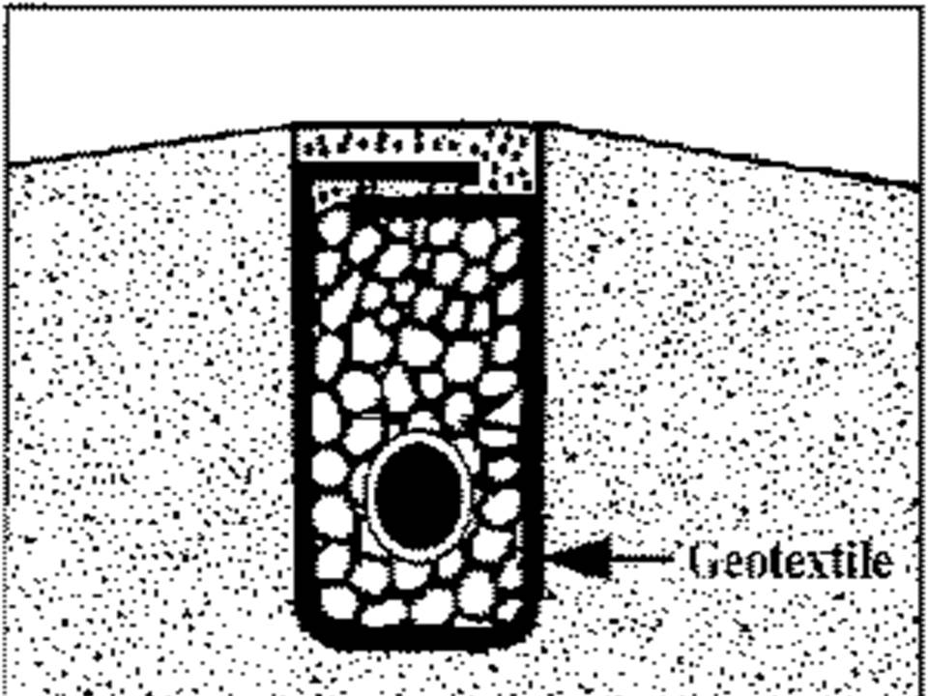

[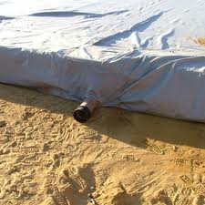](http://www.google.com.sa/imgres?start=90&hl=ar&sa=X&biw=1366&bih=647&tbm=isch&prmd=imvns&tbnid=txOe5NXDj0NydM:&imgrefurl=http://sourcecontrolshop.co.uk/index.php?main_page=product_info&cPath=3&products_id=16&docid=j7di-Wc_dzr8SM&imgurl=http://www.sourcecontrolshop.co.uk/images/products_sub/installations/Stormwater/geotextile/geotextile_non_woven_needle_punched_soakaway_protection_suds.jpg&w=300&h=300&ei=A_t9T7DrM8fDswaaw-mlDg&zoom=1)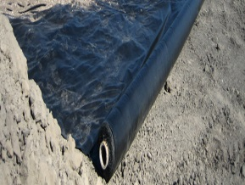 [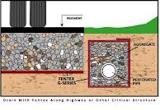](http://www.google.com.sa/imgres?start=90&hl=ar&sa=X&biw=1366&bih=647&tbm=isch&prmd=imvns&tbnid=yPHFHqQSAImodM:&imgrefurl=http://www.griffengeo.com/products.php?p=11&docid=AffGFp3DkH_LXM&imgurl=http://www.griffengeo.com/_userfiles/image/GEOTEXTILE%20tech%20drawing%20caption.jpg&w=970&h=673&ei=A_t9T7DrM8fDswaaw-mlDg&zoom=1)

**Waterproofing Function (Moisture barrier)**

Geotextile can act as waterproof materials when impregnated with bitumen or polymeric sealing materials . After impregnation , the water and vapor permeability of the fabric become very low in both cross-plane and in plane-flow.

**Protection Function**

In a variety of structures, geotextiles are used with geomembranes. Geotextile can provide long term protection of geomembranes against mechanical damage ,such as perforation and abrasion ,during and after installation .Although in many applications it is possible to identify one dominate function out of these basic functions , often other functions still perform essential roles even if they are secondary . For instance , in an unpaved road base the role of a geotextile is clearly that of a separator . However , reinforcement and filtration Functions should also be considered .

**Geotextile Applications**

The earliest uses of the geotextile concept are credited to the road builders of the ancient Roman empire who used sheepskin and heather atop the ground before placing cobblestone in constructing the Appian way. In 1926 , woven cotton fabrics were used as an early form of geotextiles in a series of road construction field by the South Carolina Highways Department .The first use of synthetic fabrics as a geotextiles was in the late 1950s, when a permeable , woven, synthetic fabric was used for erosion control in Florida.Nonwoven Geotextiles were first used in 1969 in an earthen dam as a filter under erosion protection on the upstream face. Since the early 1970s, the use of geosynthetics or geo-polymeric structures within civil-engineering constructions has expanded to such an extent that today they are almost certain to be included in any major work. Thanks to Geotextiles, roads, railway lines, drains, embankments, and dikes can now be built more easily and at lower cost. Applications of Geotextiles have been constantly expanded .As a rule , the use of Geotextiles reduces both construction costs and construction times. It is beyond the scope of this research to cover all geotextile applications. However , the researcher will try to describe some of the most common applications of geotextiles in civil engineering sector.

**Road building**

Geotextiles provides effective stabilization and critical subsoil / base course separator for paved surfaces and also stabilize and retain aggregate for unpaved surfaces , such as parking, loading lots, roads, airport runways, …etc.

**Railway tracks**

Subgrade stabilization has always been a problem to the railroads. Due to heavy dynamic load resulting from train traffic, the stony ballast is very often contaminated by rising fine particles from the underlying soil, which leads to deformation of the ground which eventually causes a gradual decrease in the bearing capacity of the upper structure. Geotextiles used in railroad stabilzation reduce maintenance and extend the track’s service life. They also prevent the loss of costly ballast , reduce rail deformation , and increase the ballast’s loadbearing capacity.

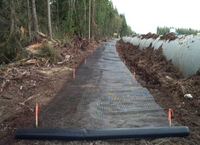 [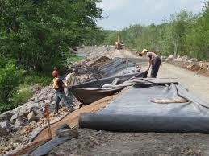](http://www.google.com.sa/imgres?start=596&hl=ar&sa=X&biw=1366&bih=647&tbm=isch&prmd=imvns&tbnid=AbaEYjlmtacIFM:&imgrefurl=http://www.triexconstruction.ca/workwaterrelatedprojects.html&docid=3BbbcuccdRuUYM&imgurl=http://www.triexconstruction.ca/images/waterrelated02.jpg&w=2560&h=1920&ei=Pvt9T9X3BIXNtAacvJCJDg&zoom=1)

[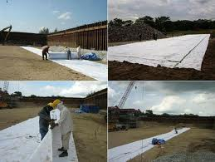](http://www.google.com.sa/imgres?start=596&hl=ar&sa=X&biw=1366&bih=647&tbm=isch&prmd=imvns&tbnid=6slXDomE2d_snM:&imgrefurl=http://www.oung.com.sg/biz_preparingGeotextile.html&docid=85EjnQS_tHBhwM&imgurl=http://www.oung.com.sg/businessArea/PreparingGeotextile.jpg&w=560&h=421&ei=Pvt9T9X3BIXNtAacvJCJDg&zoom=1)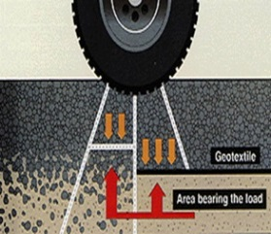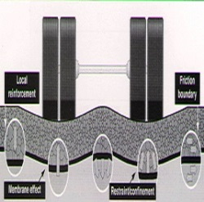

## [https://encrypted-tbn1.google.com/images?q=tbn:ANd9GcQUc28RJHopMvMCnOppNbDHKz_HdDLN5IWGJP7Te_UD3wf1oskW](http://www.google.com.sa/imgres?hl=ar&sa=X&biw=1366&bih=647&tbm=isch&prmd=imvns&tbnid=4wzBZ8btrxdKkM:&imgrefurl=http://geotextile.trademart.in/product-GeotextilesforRailways_Geotextiles_geotextile.html&docid=BK7NY3gRGg6q0M&imgurl=http://geotextile.trademart.in/is-bin/intershop.static/WFS/SellSmart-DirectoryServices-Site/SellSmart-DirectoryServices-Site/en_US/geotextile_railway_bidim.jpg&w=500&h=353&ei=-vp9T__rNoXVsga3sMWSDg&zoom=1) [https://encrypted-tbn0.google.com/images?q=tbn:ANd9GcQFZj7vqTpoo8hkSR_zRZ8pg3MVopHgxt5oDKRzVOclC1QX_FBxjgfbzbKC](http://www.google.com.sa/imgres?start=186&hl=ar&sa=X&biw=1366&bih=647&tbm=isch&prmd=imvns&tbnid=JuXUft0qdEFa8M:&imgrefurl=http://www.busytrade.com/selling-leads/1810668/Non-Woven-Geotextile.html&docid=GlF34A4WCbhrHM&imgurl=http://images-en.busytrade.com/177539800/Non-Woven-Geotextile.jpg&w=500&h=378&ei=DPt9T--LPIjPtAbawIz3DQ&zoom=1)

**Embankments on soft ground**

When embankments are constructed over weak soil such as soft clays, there can be problems with short- term instability in the form of deep- seated rotational slipping or transverse spreading of the embankment. Before the advent of geotextiles, these problems were overcome by building the embankment with very flat side slopes .A much more economic solution can be achieved by using a basal layer of geotextile reinforcement, placed over the original formation before placing of embankment fill. The geotextile will impart tensile strength to the base of the fill, thereby resisting lateral spreading, rotational failure of the underlying soft ground.

**Walls and steep sided embankments**

Unlike embankments on soft ground, walls and steep sided embankments need support from the geotextile for their

entire design life. The essence of construction is comprising the placing of the fill incorporating horizontal layers of geotextile reinforcement. As one lift of fill is completed , the geotextile is rolled out over the surface of the fill to ensure an adequate bond length.

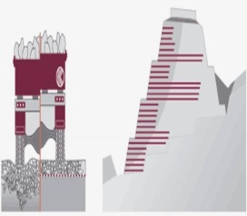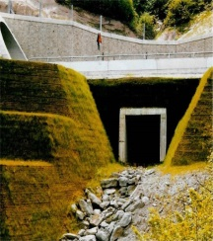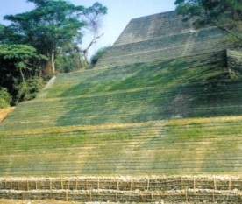

## Erosion Control

Soil erosion is a phenomenon of transportation of soil particles by exogenous wind or water action. The erosion phenomenon starts as soon as the first particle, detached from the rest of the soil, gets carried away due to the impact of splash and velocity of flow. The traditional method for controlling the erosion was by using a flexible protective structure such as rip-rap or heavy armour stones, concrete blocks, etc. The use of a geotextile filter can simplify construction of the erosion control measure, where it replace several layers of granular filter beneath rip-rap armour stones.

**Drainage applications**

With the availability of geotextile with a wide range of pore sizes and permeability, it is a comparatively simple matter to select a fabric that will filter the soil to be drained , where the drainage trench is simply lined with the filter fabrics and back filled with an aggregate that is coarse enough to act as a drainage medium .

[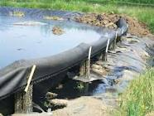](http://www.google.com.sa/imgres?start=90&hl=ar&sa=X&biw=1366&bih=647&tbm=isch&prmd=imvns&tbnid=2_bShYLlqYMjFM:&imgrefurl=http://aquaclearenvironmental.com/geotextile.htm&docid=Mr6BrM8bF6JqqM&imgurl=http://aquaclearenvironmental.com/images/geotextile1.jpg&w=350&h=263&ei=A_t9T7DrM8fDswaaw-mlDg&zoom=1)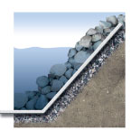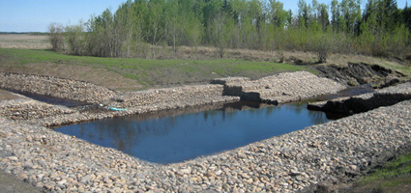

**Choosing the right geotextile**

In order to choose the right geotextile, its precise function must be known. Will it be used for separation ,or for reinforcement etc.? Will it be subjected to high or low stresses ? Is the subsoil firm or soft ? etc. All these important questions which have a bearing on the choice of geotextile and of the raw material . Because only a correctly choosen textile will satisfy the requirements