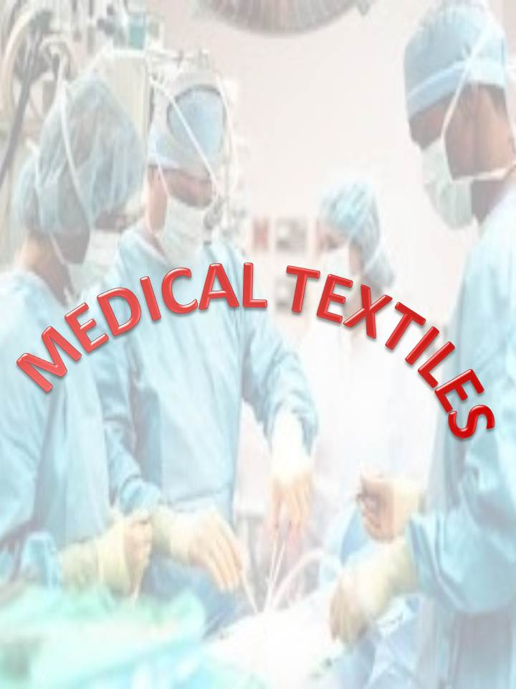

**Medical textiles**

**dr.Ibrahim .g.,e.**

Medical textiles in the industrial textile field gradually have taken an important role. Medical textiles refer to textile products often used in combination with non-textile materials which are used for the medical care of humans and animals and act as protection for personnel and equipment in medical care situation medical textiles differ from other textile products in that there is often little scope for diversification and design variation .The medical textiles section, looked at in its broadest term, is undoubtedly one of the greatest success stories of recent years, The medical and related Hygiene industries have been major users of textiles products for many years. The Huge growth of medical applications of textiles over the last 12 years or more has mirrored that the development of modern medicine and surgery has not been limited to just the volume of materials used, where medical application in addition to protective medical apparel textiles are used for implant, blood filter and surgical dressing… etc , today there has been a huge increase in both the size of the market and the variety of product available and most industry leaders at all levels of the distributions network, say that there is potential for new products and application.

**Classification of medical textiles**

Medical textiles could possible be classified by fiber type or processing route. A classification based on function is more appropriate, classification by function emphasizes aspects and different textile structure, it also emphasizes that some application requires several functions, medical textiles are capable of meeting all requirements of medical application on their own, where medical textiles includes many products with a composite structures.

So it is possible to be classified as follow:

Textiles for implantation such as (sutures, vascular grafts , fabrics for heart valves and repair, artificial joints , fabric for hernia repair, surgical reinforcement , meshes fibrous bone plates .. etc)

Non-implantable materials such as (bandages, wound dressing, plasters….etc)

Health care and Hygiene products such as (bedding, protective clothing, surgical gowns, wipe, face masks.. etc

Textiles in extracorporeal devices such as( artificial liver, lung…etc

Today medical textiles are produced and sold within a strict form of regulation and legislation. Such control is essential to protect patients, medical practitioners and manufactures .

**Textiles for implantation**

These materials used in effecting repairs to the body whether it be wound closures sutures or replacement surgery (Heart prosthesis-artificial ligaments, surgical meshes …etc) Although the natural way to replace a defective part of the body would be transplantation this is not always possible due to several reasons including availability, performance requirement… etc, Therefore physicians often have to use artificial substitute (biomaterial) such as biotextiles, of origin or synthetic material. A part used to replace a body part is referred to as prosthesis. Although textile materials depend on specific application in general, The biological requirements for a satisfactory artificial implant may be stated as follow:

1-A suitable artificial surface of the body cells to be easily adhered and grown on.

2-Porosity, which determines the rate at which tissue will grow and encapsulate the implant (implant material should be sufficiently porous.

3-Fiber diameter in general, should be smaller than the cells for their adherence, to make human tissues capable of encapsulating.

4-Biodegradability or biostability depending on the application

5-non-toxicity where fiber polymer or fabrication techniques must be –non-toxic and fibers should be free of contaminants

The Implantable material must meet mechanical requirements for the particular application biocompatibility for examples requires that the biotextiles must interact, with the host in a controlled and predictable way. In addition to these blood cells cause formation of destructive blood cloth. Application of textiles as implant include abdominal wall, artery , biohybrid organs , bone , heart valve and wall, vein, hip, joint ,ligament , tendon , trachea …etc

**Soft tissue implants**

Biomedical materials are used in applications such as soft tissue, artificial prostheses, artificial skin, patches, artificial tendon and artificial cornea. The main component of soft tissue is the human organism, therefore artificial implant, with collagen modified surface easily adhere to soft tissue, soft tissue compatible artificial materials include silicone rubber, polyurethane hydrogels, carbon fiber, collagen, silk protein and cellulose chitin.

**Tendons and ligaments**

Ligaments are the fairly elastic bands of tissue that join bones together, tendons are made of similar tissue. The most commonly replaced ligaments are those of knee. Manmade tendons have made of woven and braided porous structure coated with silicon, but nonwoven fabrics are not suitable as ligament prosthesis because of their lack of strength, woven and knitted structures are used as artificial ligaments. Braiding a carbon fiber core and a polyester sleeve have produced a material for replacing damaged ligaments as well as polyester and carbon fibers were used in twisted, knitted and narrow- woven constructions but braided fabrics with a stress strain behavior similar to a natural tendons or ligament are the most suitable structure where braided polypropylene implant usually consists of several strands that are braided into tape –like structure, A braided carbon fiber implant is typically made up of thirty –two strands of 3.000 fiber each .The requirements for ligament and tendon implants are both biological (biocompatibility – long – term stability ,and supporting tissue proliferation and bio-mechanical (physiological progressive stress strain), bio-absorbable are preferable for manufacturing of ligaments and tendon . Synthetic material can not match the fatigue resistance of natural tissue with its ability to regenerate itself so a graft should encourage the ingrowth of new collagen to form a new tendon or ligament a successful graft must match the mechanical properties of the original ligament or tendon as closely as possible and must induce adverse tissue reactions . Finally at the present time, no material has been shown to be ideal tendon where founding problem including the abrasion of the prostheses at the point of entry , leading both to malfunction and excessive tissue response to the debris and the creep of the polymer that radically alters the ability to replicate the natural mechanical response to loads, thereby leading to instability.

[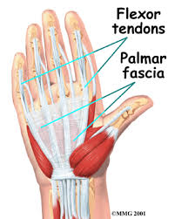](http://www.google.com.sa/imgres?hl=ar&sa=X&biw=1366&bih=587&tbm=isch&tbnid=ggfuaTj5MoxnGM:&imgrefurl=http://www.eorthopod.com/content/dupuytrens-contracture&docid=LCRPExZFX54r7M&imgurl=http://www.eorthopod.com/sites/default/files/images/hand_dupuytrens_anat01.jpg&w=320&h=400&ei=c00wUda8MeSU0QX0lYCwDQ&zoom=1&ved=1t:3588,r:28,s:0,i:169)[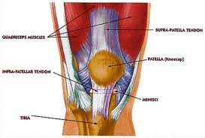](http://www.google.com.sa/imgres?hl=ar&sa=X&biw=1366&bih=587&tbm=isch&tbnid=YpFyL22iZWoZdM:&imgrefurl=http://directory.leadmaverick.com/Precision-Medical-Equipment/DallasFort-WorthArlington/TX/8/1436/index.aspx&docid=Td_56dIi7UWKUM&imgurl=http://injurysupplies.com/images/guide/kneeanatomy.gif&w=450&h=304&ei=c00wUda8MeSU0QX0lYCwDQ&zoom=1&ved=1t:3588,r:24,s:0,i:157)[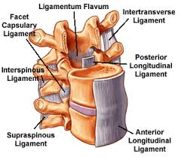](http://www.google.com.sa/imgres?hl=ar&sa=X&biw=1366&bih=587&tbm=isch&tbnid=9nFVZhSTUPvmfM:&imgrefurl=http://www.coloradospineinstitute.com/subject.php?pn=anatomy-ligaments-17&docid=EqjWYYMS-dS_DM&imgurl=http://www.coloradospineinstitute.com/graphic/bvlicense/15_dp_ligaments.gif&w=300&h=260&ei=c00wUda8MeSU0QX0lYCwDQ&zoom=1&ved=1t:3588,r:14,s:0,i:119&iact=rc&dur=905&sig=112758082456572852499&page=1&tbnh=172&tbnw=193&start=0&ndsp=18&tx=119&ty=108)[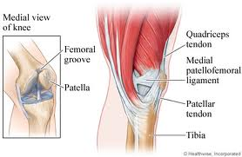](http://www.google.com.sa/imgres?hl=ar&sa=X&biw=1366&bih=587&tbm=isch&tbnid=2UGGpwyoPnNsPM:&imgrefurl=http://www.emedicinehealth.com/script/main/art.asp?articlekey=138375&ref=135313&docid=nswT4FbTuNBiLM&imgurl=http://images.emedicinehealth.com/images/healthwise/medical/hw/h9991565_002.jpg&w=460&h=300&ei=c00wUda8MeSU0QX0lYCwDQ&zoom=1&ved=1t:3588,r:19,s:0,i:134)

[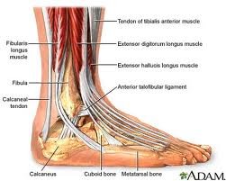](http://www.google.com.sa/imgres?hl=ar&sa=X&biw=1366&bih=587&tbm=isch&tbnid=omFTe25equ40qM:&imgrefurl=http://www.sportsmedtexas.com/Pages/anklerepair.aspx&docid=_jkJTuQfYzxxVM&imgurl=http://www.sportsmedtexas.com/PublishingImages/ankle_anatomy.jpg&w=400&h=320&ei=c00wUda8MeSU0QX0lYCwDQ&zoom=1&ved=1t:3588,r:30,s:0,i:175)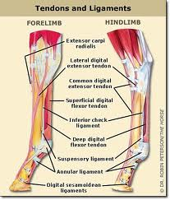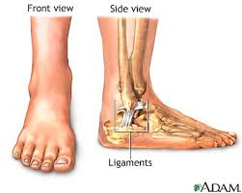[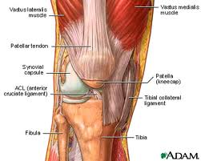](http://www.google.com.sa/imgres?hl=ar&sa=X&biw=1366&bih=587&tbm=isch&tbnid=1kbrxaH2Ct-XqM:&imgrefurl=http://www.drjemison.com/joint-pain-prolotherapy.html&docid=sYY2LeofRr4qCM&imgurl=http://www.drjemison.com/images/kneediagram.jpg&w=400&h=320&ei=c00wUda8MeSU0QX0lYCwDQ&zoom=1&ved=1t:3588,r:29,s:0,i:172)

**Surgical mesh**

Surgical mesh is used in the abdominal wall after injury or lesion caused by hernia . Prostheses made from micro-porous expanded (PTFE) such has Gore-Tex, soft tissue patch , polypropylene mesh such as (the meadox trelex) where polypropylene is resistant to infection and it is not allergenic. Mesh or fabric substrate made from a knitted non-resorbable polyester which is impregnated or developed with partially cross – linked (resorbable). The materials are loaded with anti- microbial by soaking prior to suturing to the abdominal wall margin, the porous material is a substrate which is impregnated or other wise associated with suitable substance capable of retaining the anti- microbial agent. In the composite prosthesis structure the antibiotics said to be completely surround the membrane mesh or fabric due to the interlocking (impregnated) nature of the resorbable gelatin and the non- resorbable membrane.

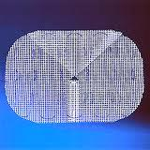[](http://www.google.com.sa/imgres?hl=ar&sa=X&biw=1366&bih=630&tbm=isch&tbnid=9H5NFbuW3AXf-M:&imgrefurl=http://medicalmalfunctions.com/&docid=OO3F8mqzbyv5hM&imgurl=http://medicalmalfunctions.com/images/mesh.gif&w=284&h=148&ei=zFEwUcWcGImohAfHqoHwAw&zoom=1&ved=1t:3588,r:93,s:0,i:364)[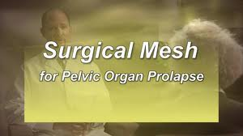](http://www.google.com.sa/imgres?start=500&hl=ar&sa=X&biw=1366&bih=630&tbm=isch&tbnid=s2yJnyMkiraSYM:&imgrefurl=http://vimeo.com/5398852&docid=zziobldsev5LxM&imgurl=http://b.vimeocdn.com/ts/175/125/17512531_640.jpg&w=640&h=360&ei=_VEwUZriNcOLhQepqYG4Ag&zoom=1&ved=1t:3588,r:55,s:500,i:169)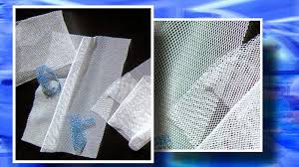

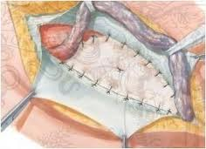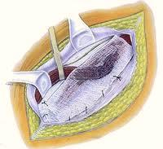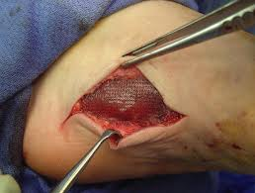[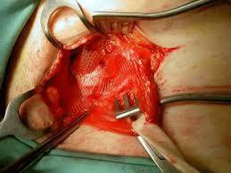](http://www.google.com.sa/imgres?start=300&hl=ar&sa=X&biw=1366&bih=630&tbm=isch&tbnid=pY0mMRmRG92A8M:&imgrefurl=http://mejfm.com/journal/Jan04/use_of_mesh_in_hernia_repair1.htm&docid=9OkYE1gozYt4WM&imgurl=http://mejfm.com/journal/Jan04/use_of4.gif&w=461&h=346&ei=-FEwUeiOLMLBhAfRsIDIDA&zoom=1&ved=1t:3588,r:31,s:300,i:97)[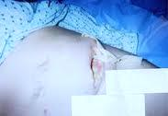](http://www.google.com.sa/imgres?hl=ar&sa=X&biw=1366&bih=630&tbm=isch&tbnid=oGkCdjW1PpeoPM:&imgrefurl=http://www.truthinmedicine.us.com/&docid=--vxtD2VUDxm9M&imgurl=http://www.truthinmedicine.us.com/images/229_Gynecare_TVT_Mesh_Complications_-_Necrotizing_Fasciitis_-_Lana_Keeton_December_25,_2001.jpg&w=229&h=158&ei=zFEwUcWcGImohAfHqoHwAw&zoom=1&ved=1t:3588,r:32,s:0,i:181)

**Sutures**

The use of sutures is one of the most common practices in the medical field and this has direct and great mudrity of the world’s population. Sutures are threads that are used to tie around vessels such as arteries to close them. Sutures are also used to close wounds produced by trauma. They can be classified into two groups (absorbable and non-absorbable). Absorbable sutures are, as the name implies, temporary due to their ability to be absorbed or decomposed by the natural reaction of the body to foreign substances. Absorbable sutures include collagen, catgut, polyglycolic acid, polylactic acid copolymer, and polydioxin. Absorbable sutures are used internally to stop internal bleeding and are degraded by the body fluid after the healing process non absorbable sutures are not dissolved or decomposed by the body’s natural action. Non absorbable sutures are divided into natural fibers (silk – cotton) and synthetic fibers (polyester, polyamide, polypropylene, steel, and teflon non-absorbable sutures materials are considered to be unresbed in the body for a long period of time . Sutures are manufactured with a wide variety of parameters, they can be mono-filaments or multi-filaments twisted together spun together or braided , they can also be dyed , undyed, coated, not coated .Taken into consideration in the manufacture and use of sutures are properties such as( stress – strain relationship , tensile strength, flexibility, wettability surface morphology, degradation, thermal properties, contact angle of knots, and elasticity , However a rough surface allows for better knot stability and security due to the friction between the surfaces. Finally it is aid that synthetic materials are better than natural materials in general and mono-filaments are better than braids minimizing the size of the sutures assists in reducing tissue reaction . Suture materials must be sterilized when used by using sterilization methods ( ionizing, radiation and ethylene oxide).

[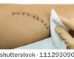](http://www.shutterstock.com/pic-111293090/stock-photo-closeup-of-a-cleaning-stitched-wound-on-a-male-leg-stitches-cm-long.html?src=05A25D98-8242-11E2-9F14-12CDACE6966E-1-16)

[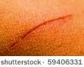](http://www.shutterstock.com/pic-59406331/stock-photo-close-up-scar-on-skin.html?src=05A25D98-8242-11E2-9F14-12CDACE6966E-1-28)[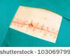](http://www.shutterstock.com/pic-103069799/stock-photo-closeup-image-of-scar-over-abdomen-after-surgery.html?src=05A25D98-8242-11E2-9F14-12CDACE6966E-1-34)[stock photo : Metal staples (satures) in a scar left from a Laparotomy/laparoscopy â€“ Close-up, Shallow Depth of field](http://www.shutterstock.com/pic-2005494/stock-photo-metal-staples-satures-in-a-scar-left-from-a-laparotomy-laparoscopy-close-up-shallow.html?src=05A25D98-8242-11E2-9F14-12CDACE6966E-1-12)[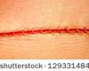](http://www.shutterstock.com/pic-129331484/stock-photo-modern-surgical-suture.html?src=05A25D98-8242-11E2-9F14-12CDACE6966E-1-96)[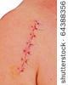](http://www.shutterstock.com/pic-64388356/stock-photo-close-up-picture-of-a-scar-on-a-female-shoulder-with-stitch.html?src=05A25D98-8242-11E2-9F14-12CDACE6966E-1-1)

[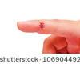](http://www.shutterstock.com/pic-106904492/stock-photo-close-up-of-a-hand-wound-with-stitches.html?src=05A25D98-8242-11E2-9F14-12CDACE6966E-1-98)

[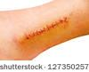](http://www.shutterstock.com/pic-127350257/stock-photo-stitches-in-the-leg-ankle.html?src=05A25D98-8242-11E2-9F14-12CDACE6966E-1-54)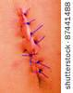[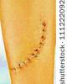](http://www.shutterstock.com/pic-111222092/stock-photo-stitched-wound.html?src=05A25D98-8242-11E2-9F14-12CDACE6966E-1-17)[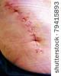](http://www.shutterstock.com/pic-79415893/stock-photo-scar-following-surgery-of-hip-joint.html?src=05A25D98-8242-11E2-9F14-12CDACE6966E-1-41)[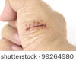](http://www.shutterstock.com/pic-99264980/stock-photo-close-up-of-a-hand-wound-with-stitches.html?src=05A25D98-8242-11E2-9F14-12CDACE6966E-1-66)

أعلى النموذج

**Biomaterials in ophthalmology**

Natural and synthetic hydrogels physically resemble the eye tissue and hence have been used in ophthalmology as soft contact lenses. Soft contact lenses are made of transparent hydrogel with high oxygen permeability, Hard contact lenses are made of (methylmethacrylate) and cellulose acetate but flexible contact lenses are made from silicone rubber.

**Dental application**

The necessary requirement for a successful dental implant are fixation in the Jaw bone and formation and maintenance of a suitable permuce cossal seal ,bone ingrowth well occur if relative movement of implants and host elevator bone is limited during the post- implantation healing period. Biopolymers are used in dental treatment to substitute for defects in tissues. Major requirements of dental polymers include translucence and abrasion resistance insolubility in oral fluid, non-toxicity, relatively high softening point ,easy fabrication and repair . The most widely used polymer for dental use is polymethylmethacrylate and its derivatives, and polysulfone .

**Orthopaedic products**

Orthopaedic products in the health care industry include arm sling, surgical collars, knee supports, splints and restraints. These products need to be stable and secure as well as comfortable, they are basically made of cotton and synthetic fibers. Synthetic Orthopaedic cushion bandages retain their cushioning effect in the moist atmosphere between skin and plaster, where non woven orthopedic cushion bandages are used under plaster casts and compression bandage for padding and comfort, They are made of polyester or polypropylene with blends of natural and other synthetic fibers . Light needle punching gives bulk and loft to the structure for greater cushion effect. These products were traditionally, made from cotton .

**Nonimplantable materials**

These materials are used for external applications on the body and may or may not make contact with skin

**Dressings**

Synthetic occlusive wound dressing are used for the treatment of burns, granulation tissue, dermatitis, ulceration, blisters, fissures, herpes, and several other skin condition. Shallow wound one that involves the loss of the epidermis, produces a scab when allowed to heal naturally without a dressing ,the scab is rigid ,dry, and porous to the oxygen required by the regenerated tissue , but acts as barrier to dirt and infection, the scab is shed when regeneration of the epermis is complete. The natural scab has disadvantages that is oxygen permeability is limited , not flexible, and that it is prone to cracking and damage and hence vulnerable to infection . Dressing are used for many purposes including protection of the wound from physical damage, covering unsightly wounds , exclusion of infection, absorption of excessive fluids from the wound , preventing of strikethrough (transfer of micro- organisms from the wound to external environment) and improving of patient comfort. Ideally dressing should be soft, pliable, to protect from further injuries, be easily applied and removed, be sterile, lint free and non -toxic. Wound care products are usually made of three layers, wound contact layer, absorbent material and base material. Wound dressing should not also adhere to the wound allowing easy removal without disturbing new tissue growth.

**Wound dressing categories**

Wound dressing might be categorized in several different ways based on composition, form and function .

**1-Film dressing**

These dressing are transparent adhesive -coated materials that are permeable to gases such as vapor and oxygen ,occurs , but impermeable to bacteria. Film dressings tend to allow accumulation of large volumes of wound exudate beneath the dressing . Film Dressings have been used experimentally with some success to control skin bacteria during surgery . film dressings are designed as surgical drapes , but typically of polymeric films spread with appropriate polysaccharide dressing .

**2-Biological dressings**

Biological dressings are at much earlier stage of development than other dressing types, these dressings are coated with treated collagen, the major application of these material is expected to be for sever burns where they may be regarded as a temporary skin substitute and to serve as anti-microbial barrier layer to prevent the loss of body fluids, proteins and electrolytes.

**3-Hydrocolloid dressings**

Hydrocolloid dressings are easily removed from the healing wound with out damage to the newly formed granulation tissue and new epidermis of the healing site . .

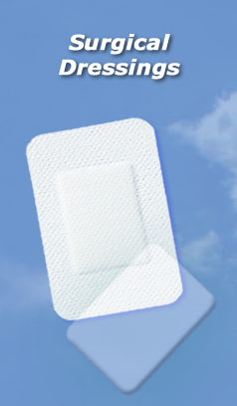 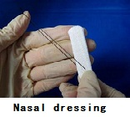 [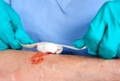](http://www.123rf.com/photo_10896976_a-nurse-tends-to-a-bloody-wound-on-an-alderly-woman.html)

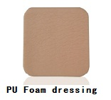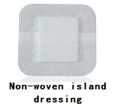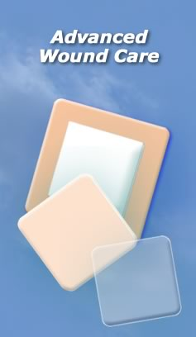

**Gauze**

Gauze is a light weight fabric of open weave made from carded cotton yarns. Gauze should be soft, pliable and absorbent. Most standard specifications require gauze to be bleached, clean and free from weaving defects, and contain no more of seed coat leaf , or other impurities. Gauzes have been used as the main wound dressing material where it was found that wound heals fast when kept in a moist occlusive condition . Coated gauze are the most common used, and most Gauzes are made from cotton in the form of a loose plain weave . General Gauze is used mostly as a dressing for direct swabs applications and is also used to treat burns and scalds. Changing a gauze dressing before the wound is healed results in removal of at least part of the scab and may destroy some of the regenerating tissues, causing pain and danger of reinfection associated with changing dressing, so gauze may be impregnated with plaster to immobilize and support broken limbs.

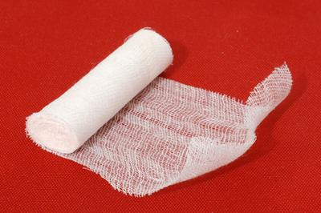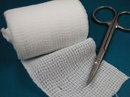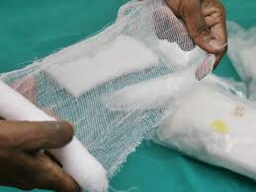

**Bandages**

The oldest known use of bandage refers to Sumeria (2100.b.c)

The Egyptians have used natural adhesive bandages as early as 4.000 years ago for various medical application. The Bandage can be woven, knitted , nonwoven and elastic or non-elastic .

**Classification of bandage**

**1-Domette bandage**

Domette bandage consists of plain weave fabric in which the warp threads are cotton and the weft threads are wool Woven cotton rolled bandage have several disadvantages, they don’t stretch, low absorbency and they ravel under stress . Nonwoven Bandages made of polyester or polypropylene with blends of natural and other synthetic fiber are used for orthopaedic uses .

**2-Stretch (elastic) bandages**

Stretch bandages can be made by twisted yarns or elastic yarns and by using knitted or woven structures. Woven stretch bandages are referred to as crepe bandage. Knitted stretch bandages are normally produced as tubes. Elastic bandages are used for sprained wrist and ankle support. Elasticity can also be obtained by using two warp beams during weaving, one under normal tension and the other under high tension. This bandage type is available in various diameters and is used for holding a dressing on a finger or limb to provide support and comfort.

**3-Compression bandage**

Compression bandages are used to exert a certain amount of compression for the treatment and prevention of deep thrombosis, leg ulceration and varicose veins, depending on the compression they provide. Compression bandages are classified as light, moderate, high and extra- high compression bandages, they can be woven, warp, or weft knitted. Compression bandage may be made of pure cotton, matt, bright viscose rayon, polyamide, elastomeric and rubber filaments .

**4-Open- weave bandage**

Open – weave bandage consists of cotton cloth of plain weave. It is similar to gauze in structure, It is a porous, disposable… strip of cotton fabric of one continuous length containing no joints, clean, and reasonably free from weaving defects. Band- ages are normally supplied in widths of 2 cm, 3 cm, 5 cm, and 7 cm, and in length of three to five meters. Open – weave bandage cloth is most often used to protect dressings , hold them in place and to give them support .

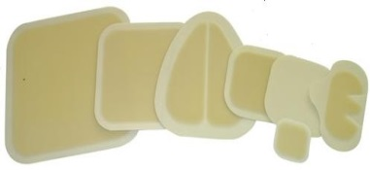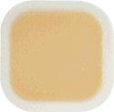[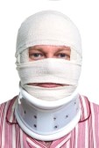](http://www.123rf.com/photo_11329645_photo-of-an-injured-man-with-a-head-bandage-and-cervical-neck-collar-isolated-on-a-white-background.html)[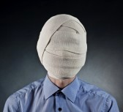](http://www.123rf.com/photo_11996681_portrait-of-the-man-with-elastic-bandage-on-a-head.html)[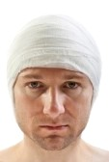](http://www.123rf.com/photo_7952258_white-bandage-on-human-brain-concussion-wound-head.html)[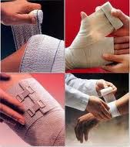](http://www.google.com.sa/imgres?start=400&hl=ar&sa=X&biw=1366&bih=587&tbm=isch&tbnid=0uRKSgHUKL-wxM:&imgrefurl=http://www.rockimpex.com/all-medical-bandages.html&docid=DHYn5m7oDWRJHM&imgurl=http://2.imimg.com/data2/IC/UA/MY-3042697/surgical-bandages-250x250.jpg&w=212&h=238&ei=b3gwUcq_ApOZhQeFq4DIAg&zoom=1&ved=1t:3588,r:53,s:400,i:163)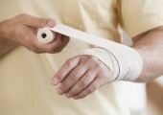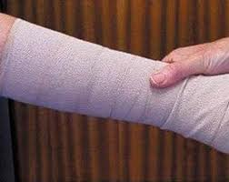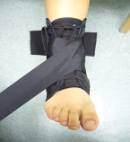

**Cushioning**

Cushioning fabrics are used to distribute mechanical stress evenly in situations where stress concentrations would be harmful, Pressure sores is probably the dominant example of the use of cushioning decubital ulcers arise when tissue is subjected to external pressure for a period of time, with ulcers occurring most rapidly with increasing pressure, such pressure sores can occur in patients recovering from surgery. In the past sheep skin was placed under the patient, to reduce the pressure on the most stress tissue by spreading the weight more evenly, however, sheep skins are naturally limited and are difficult to wash and sterilize .

[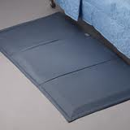](http://www.google.com.sa/imgres?start=800&hl=ar&sa=X&biw=1366&bih=587&tbm=isch&tbnid=WeAlxMa_QNv7QM:&imgrefurl=http://www.saferfalls.com/FloorCushions.html&docid=yCQQhXpVJwKE9M&imgurl=http://www.saferfalls.com/6023-4_204-C_20200x200.jpg&w=200&h=200&ei=kH0wUbqjH8K6hAeRsYDQCg&zoom=1&ved=1t:3588,r:79,s:800,i:241)[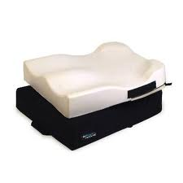](http://www.google.com.sa/imgres?start=500&hl=ar&sa=X&biw=1366&bih=587&tbm=isch&tbnid=wG__YE5wZpEW7M:&imgrefurl=http://www.homedequip.com/Default.aspx?tabid=148&docid=T4L6CjzIXc_VjM&imgurl=http://www.homedequip.com/Portals/0/pictures/manual-wheelchairs/seating-positioning/intouch-stabilite-om-cushion/stabilite-om-cushion-lg-1.jpg&w=400&h=400&ei=eX0wUf2MLcS7hAeXloCQBw&zoom=1&ved=1t:3588,r:13,s:500,i:43)[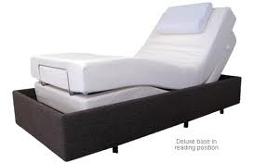](http://www.google.com.sa/imgres?start=700&hl=ar&sa=X&biw=1366&bih=587&tbm=isch&tbnid=OujV-4B5F1N5OM:&imgrefurl=http://orangefurnitureandbeds.co.nz/beds-r-us/adjustable-beds/&docid=TSEYu8A7z2tbyM&imgurl=http://orangefurnitureandbeds.co.nz/wp-content/uploads/2012/07/adjustable-beds-2.png&w=615&h=377&ei=fX0wUczePNOHhQe_8IEg&zoom=1&ved=1t:3588,r:41,s:700,i:127)[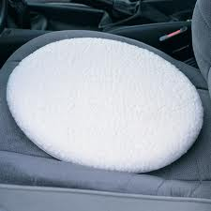](http://www.google.com.sa/imgres?start=900&hl=ar&sa=X&biw=1366&bih=587&tbm=isch&tbnid=UYA5HFnVOy4LZM:&imgrefurl=http://www.maillife.co.uk/p/cushioned-car-transfer-turntable-swivel-seat-pat85&docid=jl5G6mWrdHHYbM&itg=1&imgurl=http://www.maillife.co.uk/medias/sys_master/8812337070110.jpg&w=1000&h=1000&ei=k30wUcSVB8y5hAfm3oBQ&zoom=1&ved=1t:3588,r:83,s:900,i:253)[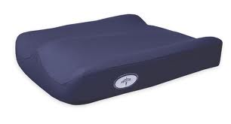](http://www.google.com.sa/imgres?start=900&hl=ar&sa=X&biw=1366&bih=587&tbm=isch&tbnid=DoYGwXBthvP_2M:&imgrefurl=http://medmartusa.com/index.php?main_page=index&cPath=136&docid=6hEGDBHVR3m7sM&imgurl=http://medmartusa.com/images/contourcushion.jpg&w=1216&h=656&ei=k30wUcSVB8y5hAfm3oBQ&zoom=1&ved=1t:3588,r:17,s:900,i:55)[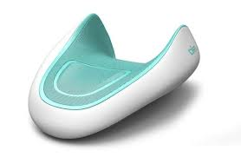](http://www.google.com.sa/imgres?start=300&hl=ar&sa=X&biw=1366&bih=587&tbm=isch&tbnid=Mq4yxxOiHe4PJM:&imgrefurl=http://www.trendhunter.com/slideshow/afternoon-nap&docid=NrmvjIJ7lMqOhM&imgurl=http://cdn.trendhunterstatic.com/thumbs/postoperative-pillow.jpeg&w=600&h=391&ei=an0wUf-JEoeGhQeJ6oCIDA&zoom=1&ved=1t:3588,r:98,s:300,i:298)