**The Supervising committee of the Chemistry Program**

**Zulfi College of Education 1435/1436 H**

**Prepared by: Dr. Gehan alaemary**

**Head of the Supervising Committee of the Chemistry Program**





**Contents:**

**1. Introduction ............................................... ............................ 7**

**2. Vision and mission .............................................. ................... 9**

**3. Program inception .............................................. .................... 11**

**4. Resolution ............................................... ............................. 12**

**5. The committee members.............................................. .................... 13**

**6. The organizational chart .............................................. .................. 14**

**7. Authorization ............................................... ........................... 18**

**8. The meetings minutes .............................................. ................ 20**

**9. The first report.............................................. .................... 21**

**10. The second report .............................................. ................... 25**

**11The third report .............................................. ................... 28**

**12. The fourth report.............................................. .................. 31**

**13. The fifth report .............................................. ................. 34**

**14. The first meeting .............................................. ................. 39**

**15. The second meeting .............................................. ................. 43**

**16. The third meeting .............................................. .................. 45**

**17. The fourth meeting .............................................. ................. 47**

**19. The fifth meeting .............................................. ............... 48**

**20. The sixth meeting .............................................. ............... 49**

**21. Achievements ................................................................... ...................... 5**

**22. Problems and obstacles .............................................. ............. 52**

**23. Recommendations ............................................... ......................... 54**

**24. Documentation and Accreditation .............................................. ............... 57**



**Vision**

**To create an educational environment characterized by a distinguished teaching quality, scientific research and community service according to the international quality standards.**

**Mission:**

**The Department is committed to providing distinguished education that combines knowledge and innovation in the field of chemistry, and forming qualified graduates to meet the labor market requirements according to international quality standards**

**Objectives:**

**1- To obtain an advanced academic level of graduates in the light of the quality standards.**

**2. To prepare scientific competencies majored in chemistry that will contribute to community service and the developing programs and plans in the fields of education, health, industry and scientific research.**

**3. To Contribute to the scientific knowledge and progress through the academic and scientific research.**

**4. To help spreading scientific research by holding seminars and conferences.**

**5- To serve the community in both the governmental and private sectors through raising awareness about chemistry programs and exchange of experiences.**

**6- To make use of electronic programs for presenting the latest educational programs in the field of chemistry.**

**7. To enhance the faculty performance through training courses, seminars and scientific conferences.**

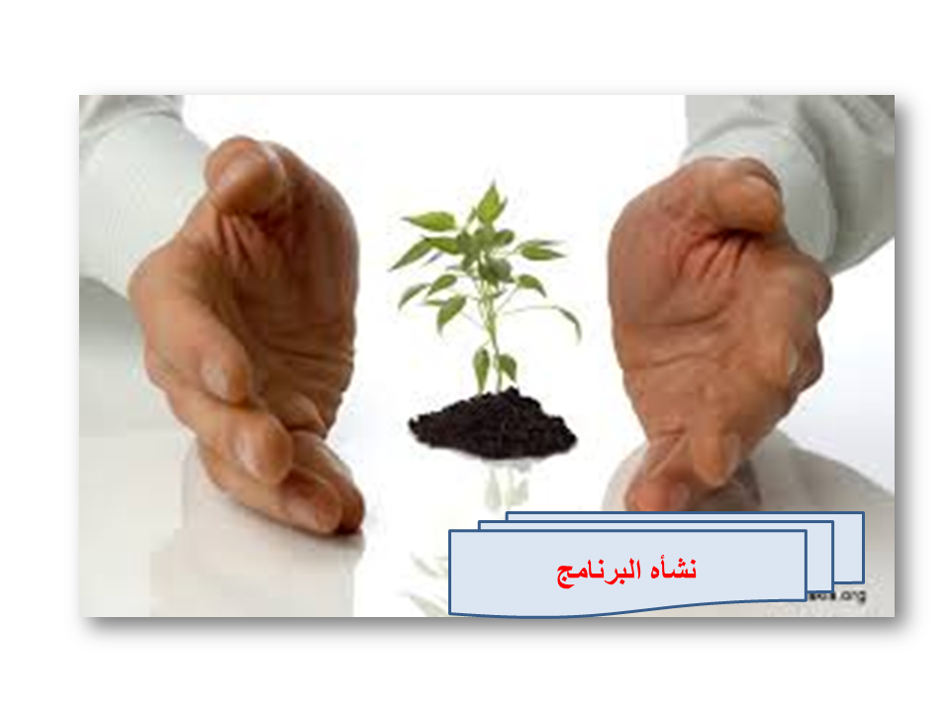

**The program inception:**

**The Resolution**

**The chemistry department Council in the Zulfi College of education has agreed upon forming the Supervising Committee of the Chemistry Program in the department during its meeting according to the following**

**The committee members according to its forming Resolution**

|  |  |  |
| --- | --- | --- |
| **Status** | **Name** | **N** |
| **Head** | **Dr. Gehan Abdel-Aziz al-aemary** | **1** |
| **member** | **Dr. Nawal Mahjoub Suleima** | **2** |
| **member** | **Dr. Amani Hassan Ahmed Saleh** | **3** |
| **member** | **Dr. Manal Mohamed Mohamed Salem** | **4** |
| **member** | **A. Ibtihaj Hassan Mohammed Hassan** | **5** |
| **member** | **A. Emna Mohammad Qasim Shtiwi** | **6** |
| **member** | **A. Ines Talal Juhani** | **7** |

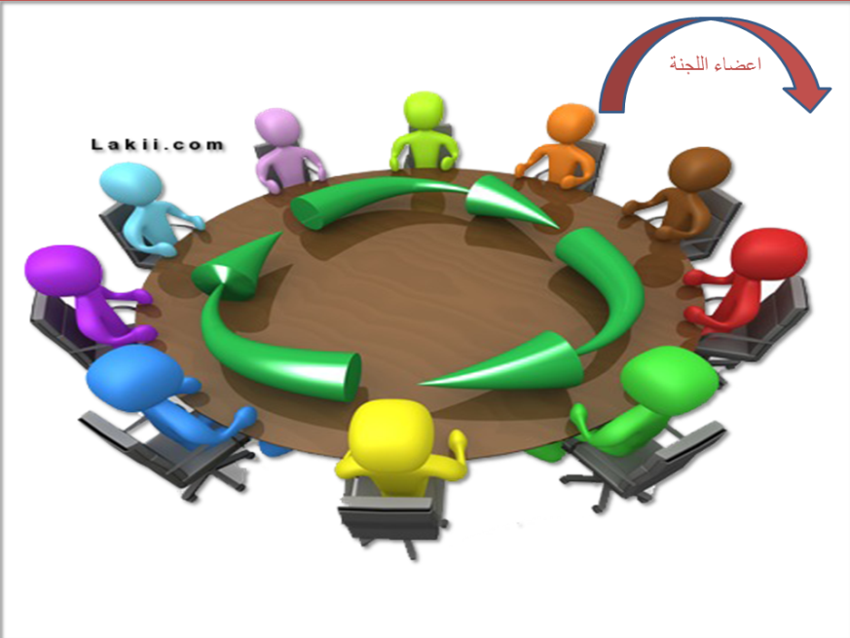

**The committee members**

The Program Supervising Committee:

|  |  |  |  |
| --- | --- | --- | --- |
| **Name** | **Academic Degree** | **Specialty** | **University E-mail** |
| **Dr. Gehan Abdel-Aziz al-Aemary** | **Associate professor** | **Biochemistry** | **g.alomayri@mu.edu.sa** |
| **Dr. Nawal Mahjoub Suleiman** | **Assistant professor** | **Organic Chemistry** | [**n.suleman@mu.edu.sa**](mailto:n.suleman@mu.edu.sa) |
| **Dr. Amani Hassan Ahmed Saleh** | **Assistant**  **professor** | **Organic Chemistry** | **ah.Ahmed@mu.edu.sa** |
| **Dr. Manal Mohamed Mohamed Salem** | **Assistant professor** | **Physical chemistry** | **m.salem@mu.edu.sa** |
| **A. Ibtihaj Hassan Mohammed Hassan** | **Lecturer** | **Physical chemistry** | **e.elhasan@mu.edu.sa** |
| **A / Mouna Nasser Al-Fawzan Al-Fawzan** | **Lecturer** | **Biology - Parasitology** | [**m.alfouzan@mu.edu.sa**](mailto:m.alfouzan@mu.edu.sa) |
| **A. Emna Mohammad Qasim Shtiwi** | **Lecturer** | **Analytical Chemistry** | **shtaiwi@mu.edu.sa‏a.** |
| **A. Ines Talal Juhani** | **Lecturer** | **Inorganic Chemistry** | **enasaljohani@hotmail.com** |
| **A. Widad Nafaa Meshaal Alsagayani** | **Instructor** | **Chemistry** | [**w.alsiqiani@mu.edu.sa**](mailto:w.alsiqiani@mu.edu.sa) |
| **A. Ruba Ali Abdul Karim al-Madid** | **Instructor** | **Chemistry** | **r.almudeed@mu.edu.sa** |
| **A.Anoud Abdul Aziz Kabalan Aljguany** | **Instructor** | **Chemistry** | **a.aljaghwani@ mu.edu.sa** |
| **A. Afnan Abdul Rahman Ataiwallah** | **Instructor** | **Chemistry** | **Scholarship** |

**The Organization of the Supervising Committee:**

The Academic Advisory Committee under the supervision of A.Emna Shtiwi

The Scientific Research and Higher Education Committee under the supervision of Dr. Nawel Mahjoub

The Students’ Cases Committee under the supervision of Dr. Afef Sherif

The Graduates Committee under the supervision of Dr. Afef Sherif

The Laboratories Committee under the supervision of Dr. Ameni al-Hassan

The Quality Committee which includes other subcommittees.

**The Organization of the quality Committee**

The Quality support Committee: A. Emna Shtiwi

A. Afnan al-Tiwalah

A. Nada Addiwish

The Performance Evaluation Committee: Dr. Afaf Sherif

A. Wided Siqyeni

A. Ruba al-Madid

The Academic Accreditation Committee: Dr. Nawel Mahjoub

Dr. Gehan Alaemary

A. Noura Doussari

The Strategic Planning Committee: Dr. Gehan Alaemary

Dr. Ameni Hassan

A. Imen Melhem

The Quality Assurance Committee: A. Ibtehaj al-Hassan

A. Mariem al-Autaibi

A. Muznah Abdulkarim

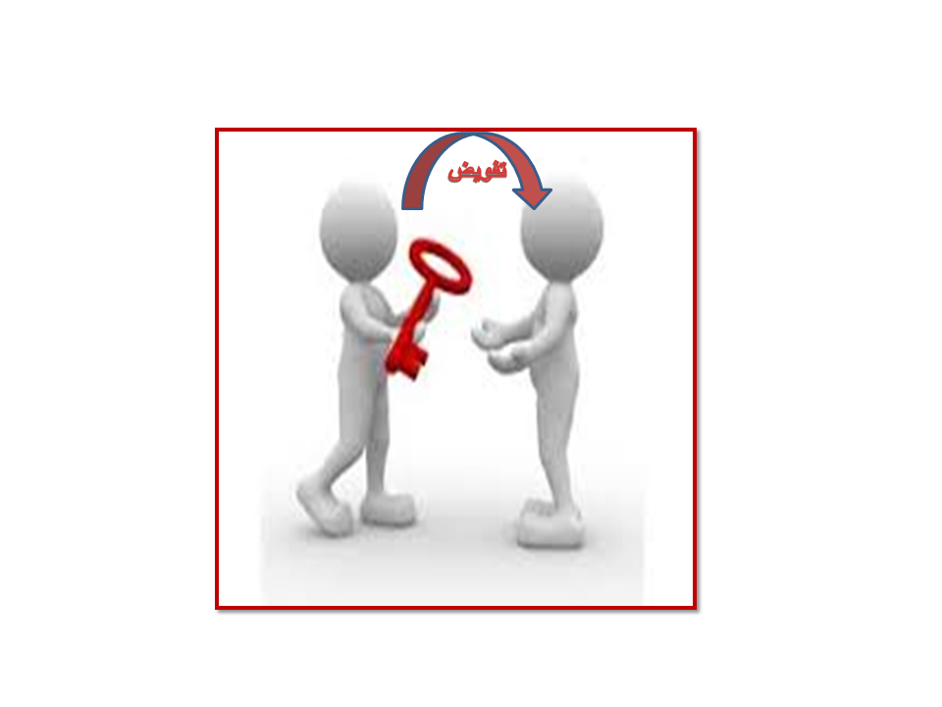

**Authorization:**

**Her Excellency / Dr. Nawal El Mahjoub Suleimen May Allah protect her**

**May Allah help and guide you. Due to my engagements, I will not be able to attend this week. Accordingly, you are authorized to carry out the educational, financial and administrative affairs during my leave of absence .I’m grateful for your cooperation. May Allah help you.**

**Dr. Gehan Alaemary**

**Head of the Supervising Program Committee**

**Dr. Gehan Alaemary Associate Professor of Biochemistry and Head of the Supervising Committee of the Chemistry Bachelor program of Education, has authorized Dr. Amani Hassan, Assistant Professor of Organic Chemistry, to do her work during her leave of absence.**

**Dr. Gehan Alaemary**

**Committee Head of the Supervising Progra**m



**The meeting minutes:**

**The meeting minutes of the Program Supervising Committee**

**The minutes of the first meeting of the Program supervising Committee:**

|  |  |  |  |
| --- | --- | --- | --- |
| **24/10/1435 H** | **Date** | **The Zulfi college of Education** | **The college/ the department** |
| **9.30 am** | **Time** | **1** | **Meeting number** |

**First: The members of the committee according to its forming resolution**

|  |  |  |  |  |  |
| --- | --- | --- | --- | --- | --- |
| **م** | **Name** | **Status** | **Present** | **Absent** | **Excuse** |
| **1** | **Dr Gehan Abdel-Aziz al-Aemary** | **Head** | **√** |  |  |
| **2** | **Dr. Nawal Mahjoub Suleiman** | **Member** | **√** |  |  |
| **3** | **Dr. Amani Hassan** | **Member** | **√** |  |  |
| **4** | **Ibtehaj Hassan** | **Member** | **√** |  |  |
| **5** | **A. EmnS shtiwi** | **Member** | **√** |  |  |
| **6** | **A. Ines al-Jahni** | **Member** | **√** |  |  |
| **7** | **Dr. Manel Mohamed Mohamed Salem** | **Member** | **√** |  |  |

**Second;**

|  |  |  |
| --- | --- | --- |
| **م** | **The theme** | Its source |
| **1** | Restructuring all the Department committees and allotting their tasks and objectives to avoid any overlapping tasks between the committees, in addition to identifying the action plan for each committee along with their timetables. | The Department |
| **2** | **Rewriting the Program’s vision, mission and objectives to comply with the College message and objectives.** | The department |
| **3** | **Meeting with the new students and assigning their Academic Advisors.** | The department |
| **4** | **Distributing the program self-evaluation on the committees according to their working scope.** | The Department |
| **5** | **Any other Business** | **The department** |

**Dr. Jihan Al Amiri started the meeting wishing everyone a new academic year full of success. She expressed her appreciation of all the efforts made last year and welcomed the new teaching members. Then, the committee coordinator listed the meeting agenda.**

**Third: Deliberations and Recommendations:**

|  |  |
| --- | --- |
| **The first theme** | **Restructuring all the department committees and allotting their tasks and objectives to avoid any overlapping tasks between the committees.** |
| **The theme resume and deliberation** | **Discussing the committees restructuring and tasks distribution.** |
| Recommendation | **Providing each committee coordinator with the tasks**  **Identifying the action plan and setting a timetable for the committees tasks** |
| **The recommendation Document** | **The modified committees are attached** |

|  |  |
| --- | --- |
| **Second theme** | **Rewriting the Program’s vision, mission, and objectives to comply with the college mission and objectives.** |
| **The theme résumé and deliberation** | T**he Program’s vision, mission, and objectives were modified to comply with the college mission and objectives.** |
| **The Recommendation** | **To publish the modified vision, mission and objectives of the Program via the available means and notify the Program relative parties of these modifications.** |
| **The recommendation document** | **The new form of the vision, mission and objectives** |

|  |  |
| --- | --- |
| **The third theme** | **Meeting with the new students and assigning their academic advisors.** |
|  | **Assigning the Academic advisors for the new students and explaining the Academic Advisory tasks to the new teaching members which include solving the student’s academic problems, helping them s with their courses schedule, courses deletion and addition, informing them with the Program sections as well as the behavioral rules adopted in the college, introducing the department teaching faculty and leading the students to the classrooms and laboratories.** |
| **Recommendation** | **Each Academic Advisor in the Program has to abide bywhat has been already approved.** |
| **The Recommendation document** | **The Program Academic Advisory Guide** |

|  |  |
| --- | --- |
| **The Fourth Theme** | **Distributing the program self-evaluation on the committees according to their working scope.** |
| The theme abstract and deliberation | **The program self-evaluation was distributed on the committees** |
| **Recommendation** | **Providing proofs for the fulfilled requirements and restricting the unfulfilled ones to set its improvements priorities.** |
| **The recommendation document** | The program self-evaluation |

**Fourth: The Present members’ signatures**

|  |  |  |  |
| --- | --- | --- | --- |
| **م** | **Name** | **Status** | **Signature** |
| **1** | **Dr. Gehan Abdel-Aziz al-Aemary** | **Head** |  |
| **2** | **Dr. Nawal Mahjoub Suleiman** | **Member** |  |
| **3** | **Dr. Ameni Hassan** | **Member** |  |
| **4** | **Ebtihaj al-Hassan** | **Member** |  |
| **5** | **A. Emna shtiwi** | **Member** |  |
| **6** | **A. Ines al-Jahni** | **Member** |  |
| **7** | **Dr. Manel Mohamed Mohamed Salem** | **Member** |  |

**Fifth: Modifications and notes**

**The minutes of the second meeting of the Program Supervising Committee :**

|  |  |  |  |
| --- | --- | --- | --- |
| **The college/the department** | The college of Education of Zulfi | Date | 5/11/1435 H |
| Session number | **2** | **Time** | **9.**9.30 am |

**First: The members of the committee according to its forming resolution:**

|  |  |  |  |  |  |
| --- | --- | --- | --- | --- | --- |
| **م** | **Names** | **Status** | **Present** | **Absent** | **Absence excuse** |
| **1** | **Dr. Gehan Abdel-Aziz al-Aemary** | **Head** | **√** |  |  |
| **2** | **Dr. Nawal Mahjoub Suleiman** | **Member** | **√** |  |  |
| **3** | **Dr. Ameni Hassan** | **Member** | **√** |  |  |
| **4** | **Ibtihaj al-Hassan** | **Member** | **√** |  |  |
| **5** | **A. Emna shtiwi** | **Member** | **√** |  |  |
| **6** | **A. Ines al-Jahni** | **Member** | **√** |  |  |
| **7** | **Dr. Manel Mohamed Mohamed Salem** | **Member** | **√** |  |  |

**Second: The schedule of the session members:**

|  |  |  |
| --- | --- | --- |
| **م** | **Theme** | **Source** |
| **1** | **Discussing the compatibility between the student’s learning outputs and the program objectives sent by the committee of the Educational Programs Development.** | **The Department** |
| **2** | **Discussing the compatibility between the learning outputs for the Chemistry Program with the Learning outputs of the National Entity**  **Qualifications for Assessment and Accreditation sent by the committee of Educational Program Development.** | **The Department** |

|  |  |
| --- | --- |
| **First theme** | **Discussing the compatibility the student’s learning outputs and the program objectives sent by the committee of the Educational Programs Development** |
| **The theme abstract and Deliberation** | **The compatibility between the student’s learning outputs and the program objectives sent by the committee of the Educational Programs Development was discussed.** |
| **Recommendation** | **Working on creating a form that is compatible with the courses specifications and adopting the already approved consistency between the students’ learning outcomes and the program objectives.** |
| **The recommendation document** | **The form and the specifications** |

|  |  |
| --- | --- |
| **الموضوع الثاني** | **Discussing the compatibility between the learning outputs for the Chemistry Program with the Learning outputs within the Qualifications national framework of the National Entity for Assessment and Accreditation sent by the committee of Educational Program Development.** |
| **ملخص وصف الموضوع ومناقشته** | **تم**  **Discussing the compatibility between the learning outputs for the Chemistry Program with the Learning outputs within the Qualifications national framework of the National Entity for Assessment and Accreditation sent by the committee of Educational Program Development.** |
| **التوصية** | **عم**  **Creating a form that is compatible with the courses specifications and adopting the already approved consistency between the students’ learning outcomes and the program objectives.** |
| **مستند التوصية** | **The outputs of the National Entity for Assessment and Academic Accreditation.** |

**Fourth: The present members’ signatures**

|  |  |  |  |
| --- | --- | --- | --- |
| **م** | **Name** | **Status** | **Signature** |
| **1** | **Dr.Gehan Abdel-Aziz al-Aemary** | **Head** |  |
| **2** | **Dr. Nawel Mahjoub Slimen** | **Member** |  |
| **3** | **Dr. Ameni Hassan** | **Member** |  |
| **4** | **Ibtihej al-Hassan** | **Member** |  |
| **5** | **A. Emna Shtiwi** | **Member** |  |
| **6** | **A. Ines al-Jahni** | **Member** |  |
| **7** | **Dr. Mane Mohamed Mohamed Salem** | **Member** |  |

**Fifth : Modifications and notes**

**The minutes of the third meeting of the Program Supervising Committee**

|  |  |  |  |
| --- | --- | --- | --- |
| **The college/ the Department** | The Zulfi College of Education | Date | 12/11/1435 H |
| **Session number** | **3** | Time | **.**9.30 am |

**First: The committee members according to its forming resolution**

|  |  |  |  |  |  |
| --- | --- | --- | --- | --- | --- |
| **م** | **Names** | **Status** | **Present** | **Absent** | **Absence excuse** |
| **1** | **DrGehan Abdel-Aziz al-Aemary** | **Head** | **√** |  |  |
| **2** | **Dr. Nawal Mahjoub Suleiman** | **Member** | **√** |  |  |
| **3** | **Dr. Ameni Hassan** | **Member** | **√** |  |  |
| **4** | **Ibtihaj al-Hassan** | **Member** | **√** |  |  |
| **5** | **A. Emna shtiwi** | **Member** | **√** |  |  |
| **6** | **A. Ines al-Jahni** | **Member** | **√** |  |  |
| **7** | **Dr. Manel Mohamed Mohamed Salem** | **Member** | **√** |  |  |

**Second: the session members’ schedule**

|  |  |  |
| --- | --- | --- |
| **م** | **Theme** | **Its source** |
| **1** | **Discussing the rubrics form for the learning outputs and the performance indicators (form 9) sent by the Committee of Educational Programs Evaluation.** | **The department** |
| **2** | **Discussing the form for the evaluation techniques for the learning outcome (form 11) sent by the Committee of Educational Programs Evaluation.** | **The department** |
| **3** | **Any Other Business** |  |

|  |  |
| --- | --- |
| **Theme 1** | **Discussing the rubrics form for the learning outputs and the performance indicators (form 9) sent by the Committee of Educational Programs Evaluation.** |
| **Topic Summary** | **The rubrics form for the learning outputs and the performance indicators (form 9) sent by the Committee of Educational Program Development was discussed.** |
| **Recommendations** | **Adopting the learning outputs and the performance indicators form (form 9) and sending it to the Committee of Educational Programs Development.** |
| **Recommendation Document** | **The form 9 sent to the committee of Educational Programs Development** |

|  |  |
| --- | --- |
| **The Second theme** | **Discussing the form of the evaluation techniques for the learning outcome (form 11) sent by the Committee of Educational Programs Evaluation.** |
| **The theme abstract and deliberation** | **The form of the evaluation techniques for the learning outcome (form 11) sent by the Committee of Educational Programs Evaluation was discussed.** |
| **The recommendation** | **Adopting the form for the learning outcome (form 11) sent by the Committee of Educational Programs Evaluation.** |
| **The recommendation document** | **Form 11 sent by the Committee of the Educational Programs Development** |

**Fourth: The Present member(s signatures**

|  |  |  |  |
| --- | --- | --- | --- |
| **م** | **Name** | **Status** | **signature** |
| **1** | **Dr. Gehan Abdalaziz Aemary** | **Head** |  |
| **2** | **Dr. Nawel Mahjoub Sulimen** | **Member** |  |
| **3** | **Dr. Amani Hassan** | **Member** |  |
| **4** | **Ibtihej al-hassan** | **Member** |  |
| **5** | **A. Emna shtiwi** | **Member** |  |
| **6** | **A. Ines al-Juhani** | **Member** |  |
| **7** | **Dr. Manel Mohamed Mohamed Salem** | **Member** |  |

**Fifth: Modifications and notes**

**The minutes of the fourth meeting of the Program Supervising Committee:**

|  |  |  |  |
| --- | --- | --- | --- |
| **The college/the department** | The Zulfi College of Education | Date | **/12/1435هـ** |
| **Session number** | **4** | Time | 9.30 am |

**First: The members of the committee according to its forming resolution**

|  |  |  |  |  |  |
| --- | --- | --- | --- | --- | --- |
| **م** | **Name** | **Status** | **Present** | **Absent** | **Excuse** |
| **1** | **Dr. Gehan Abdulaziz Aemary** | **Head** | **√** |  |  |
| **2** | **Dr. Nawel Mahjoub Slimen** | **Member** | **√** |  |  |
| **3** | **Dr. Ameni Hassan** | **Member** | **√** |  |  |
| **4** | **Ibtehaj al-Hassan** | **Member** | **√** |  |  |
| **5** | **A. Emna Shtiwi** | **Member** | **√** |  |  |
| **6** | **A. Ines al-Jahni** | **Member** | **√** |  |  |
| **7** | **Dr. Manel Mohamed Mohamed Salem** | **Member** | **√** |  |  |

**Second: the session members schedule**

|  |  |  |
| --- | --- | --- |
| **م** | **The theme** | **Its source** |
| **1** | **Reviewing the quality improvement plan for the academic year 1435/1436 H** | **The department** |
| **2** | **Reviewing the Course specification for the academic year 1435/1436 H** | **Department** |

**Third: Deliberations and recommendations**

|  |  |
| --- | --- |
| **The first theme** | **Reviewing the Quality improvement plan of the Program for the Academic year 1435/1436 H** |
| **The theme abstract and deliberation** | **Discussing the quality improvement plan of the Program for the academi year 1435/1436 H** |
| **Recommendation** | **To hold regular meeting to improve the quality plan** |
| **The recommendation Document** | **The improvement plan for the academic year 1435/1436 H** |

|  |  |
| --- | --- |
| **The second theme** | **Reviewing the Program specification for the academic year 1435/1436 H** |
| **The theme abstract and deliberation** | **Discussing the program specifications in both the Arabic and English Languages and their compatibility with the strategic plan.** |
| **Recommendation** | **Sustaining the new updated specification** |
| **The recommendation Document** | **The Program specification plan** |

**Fourth: the Present member’s signatures:**

|  |  |  |  |
| --- | --- | --- | --- |
| **م** | **Name** | **Status** | **Signature** |
| **1** | **Dr. Gehan Abdulaziz Al-aemary** | **Head** |  |
| **2** | **Dr. Nawel Mahjoub Slimen** | **Member** |  |
| **3** | **Dr. Ameni Hassan** | **Member** |  |
| **4** | **Ibtehaj al-Hassan** | **Member** |  |
| **5** | **A. Emna Shtiwi** | **Member** |  |
| **6** | **A. Ines al-Jahni** | **Member** |  |
| **7** | **Dr. Manel Mohamed Mohamed Salem** | **Member** |  |

**Fifth: Modifications and notes**

**The minutes of the fifth meeting of the Program Supervising Committee**

|  |  |  |  |
| --- | --- | --- | --- |
| **The college/the Department** | The Zulfi College of Education | Date | **/12/1435هـ** |
| **The session number** | **5** | Date | **9.30 a.m** |

**First: The members of the committee according to its forming resolution:**

|  |  |  |  |  |  |
| --- | --- | --- | --- | --- | --- |
| **م** | **Name** | **Status** | **Present** | **Absent** | **Excuse** |
| **1** | **Dr. Gehan Abdulaziz Al-aemary** | **Head** | **√** |  |  |
| **2** | **Dr. Nawel Mahjoub Slimen** | **Member** | **√** |  |  |
| **3** | **Dr. Ameni Hassan** | **Member** | **√** |  |  |
| **4** | **Ibtehaj al-Hassan** | **Member** | **√** |  |  |
| **5** | **A. Emna Shtiwi** | **Member** | **√** |  |  |
| **6** | **A. Ines al-Jahni** | **Member** | **√** |  |  |
| **7** | **Dr. Manel Mohamed Mohamed Salem** | **Member** | **√** |  |  |

**Second: The session member’s schedule**

|  |  |  |
| --- | --- | --- |
| **م** | **The theme** | **Its source** |
| **1** | **Reviewing the course specification** | **Department** |
| **2** | **Any other business** |  |

**Third: Deliberations and recommendations:**

|  |  |
| --- | --- |
| **The first theme** | **Reviewing the courses specification** |
| **The subject abstract and deliberation** | **Discussing the specification of the specialized courses received from the Study Plans Committee** |
| **The recommendation** | Identifying the Plans Committee modifications |
| **Recommendation Document** | **The courses specification** |

**Fourth: The present member’s signature:**

|  |  |  |  |
| --- | --- | --- | --- |
| **م** | **Name** | **Status** | **Signature** |
| **1** | **Dr. Gehan Abdulaziz Al-aemary** | **Head** |  |
| **2** | **Dr. Nawel Mahjoub Slimen** | **Member** |  |
| **3** | **Dr. Ameni Hassan** | **Member** |  |
| **4** | **Ibtehaj al-Hassan** | **Member** |  |
| **5** | **A. Emna Shtiwi** | **Member** |  |
| **6** | **A. Ines al-Jahni** | **Member** |  |
| **7** | **Dr. Manel Mohamed Mohamed Salem** | **Member** |  |

**Fifth: Modifications and notes**

**The minutes of the sixth meeting of the Program Supervising Committee**

|  |  |  |  |
| --- | --- | --- | --- |
| **The College/ the Department** | The Zulfi College of Education | Date | **/12/1435هـ** |
| **Session number** | **6** | Time | 9.30 am |

**First: the members of the committee according to its forming resolution:**

|  |  |  |  |  |  |
| --- | --- | --- | --- | --- | --- |
| **م** | **Name** | **Status** | **Present** | **Absent** | **Excuse** |
| **1** | **Dr.gehan Abdulaziz Al-aemary** | **Head** | **√** |  |  |
| **2** | **Dr. Nawel Mahjoub Slimen** | **Member** | **√** |  |  |
| **3** | **Dr. Ameni Hassan** | **Member** | **√** |  |  |
| **4** | **Ibtehaj al-Hassan** | **Member** | **√** |  |  |
| **5** | **A. Emna Shtiwi** | **Member** | **√** |  |  |
| **6** | **A. Ines al-Jahni** | **Member** | **√** |  |  |
| **7** | **Dr. Manel Mohamed Mohamed Salem** | **Member** | **√** |  |  |

**Timetables of the committees members :**

|  |  |  |
| --- | --- | --- |
| **م** | **The theme** | **Its source** |
| **1** | **Discussing the Department Strategic Plan** |  |
| **2** | **Implementing the College Strategic Plan** |  |
| **3** | **Upcoming tasks** |  |

**Third: Discussions and Deliberations**

|  |  |
| --- | --- |
| The first theme | **Discussing the Department Strategic Plan** |
| **Topic Summary** | **The Program Strategic Plan presented by the Program Committee and its compatibility with the College Strategic Plan were discussed.** |
| **Recommendations** | **Applying the necessary modifications from the part of the committee of the Program Strategic Plan.** |
| **Recommendation Document** | **The Strategic Plan of the program and the College** |

|  |  |
| --- | --- |
| **Second Topic** | **Implementing the College Strategic Plan** |
| **Topic Summary** | **The Strategic Plan sent by the College unit of Quality and how to implement it were discussed.** |
| **Recommendation** | **Setting a plan to implement the College Strategic Plan.** |
| **Recommendation Document** | **The Strategic Plan of the program and the College.** |

**Fourth: The present member’s signature:**

|  |  |  |  |
| --- | --- | --- | --- |
| **م** | **Name** | **Status** | **Signature** |
| **1** | **Dr. gehan Abdulaziz Al-aemary** | **Head** | **Department** |
| **2** | **Dr. Nawel Mahjoub Slimen** | **Member** | **Department** |
| **3** | **Dr. Ameni Hassan** | **Member** |  |
| **4** | **Ibtehaj al-Hassan** | **Member** |  |
| **5** | **A. Emna Shtiwi** | **Member** |  |
| **6** | **A. Ines al-Jahni** | **Member** |  |
| **7** | **Dr. Manel Mohamed Mohamed Salem** | **Member** |  |

**Fifth: the modifications and notes**

**The first committee meeting**

|  |  |  |  |
| --- | --- | --- | --- |
| **First** | **Session** | **Quality** | **Committee** |
| **9.00 am** | **Time** | **22/10/1435 H** | **Date** |

**First: the committee members**

|  |  |  |  |  |
| --- | --- | --- | --- | --- |
| **signature** | **Presence** | **Status** | **Member** | **م** |
|  | **Present** | **Head** | **Dr.Gehan abdulaziz** | **1** |
|  | **Present** | **Coordinator** | **A. Ibtehaj al-Hassan** | **2** |
|  | **Present** | **Member** | **Dr. Nawel Mahjoub** | **3** |
|  | **Present** | **Member** | **Dr. Amani Hassan** | **4** |
|  | **Present** | **Member** | **A. Emna shtiwi** | **5** |
|  | **Present** | **Member** | **A. Ines al-Jahni** | **6** |
|  | **Present** | **Member** | **A. Wided al-Siqyeni** | **7** |
|  | **Present** | **Member** | **A. Ruba al-Madid** | **8** |
|  | **Present** | **Member** | **A. Imen al-Milhim** | **9** |
|  | **Present** | **Member** | **A. Miznah Abdulkarim** | **10** |

**The session agenda:**

**1- Reviewing all the specifications of the specialty courses.**

**2- Reorganizing the Quality Committees.**

Recommendations:

1/ All the department faculty members were asked to review the courses specifications each according to her specialty.

2/ The Quality Committees have been restructured.

The Quality unit is composed of five principal committees as follows:

1. Quality-support Committee.

2. Performance-evaluation Committee.

3. Academic Accreditation Committee.

4. The Strategic Planning Committee.

5. Quality Assurance Committee.

**1**

**1/The Quality-support Committee:**

**The Committee Objective:**

**To Reinforce the Qualityand Accreditation concepts, improve communication between the department and the beneficiaries and enhance the skills of the department members through a training program that meets their needs,in addition to creating a comprehensive database that includesthe different educational, researchand community activities of the department and restricting the department various teaching and learning styles, resources and equipments.**

**The committee structuring:**

**- A / Amani Hassan Head**

**- A / Ines al-Jahani Member**

**- A / Ruba al-Madid Member**

**The Committee assignments:**

**A) Information Technology and database**

**1. Contacting the Department members to prepare lists with the students’ educational and practical needs for the current and the coming academic year.**

**2. Preparing the lists of the current and future Laboratories equipments for the female.**

**3. Creating a database with the available department textbooks and the needed books needed.**

**B) Training**

**C)Announcement and Media**

**- Collecting the required data and uploading them on the department site.**

**- Collecting the department and faculty member’s news as well as the students’ activities and achievements on a regular basis.**

**- Managing with the portal coordinator to announce the department news on the College and the University sites.**

**- Learning and Teaching resources.**

**2/ The Performance Evaluation Committee**

**- The committee objective:**

**To Study, review and modify the evaluation and examination methods and their likelihood for improvement, as well as to design, codify and distribute questionnaires and opinion polls, then convert and analyze their results to write a report about their ultimate objective and the obtained results for all the department different categories, activities and fields for the purpose of boosting the educational, research and community process to meet the accreditation standards.**

**The committee structuring: -**

**Head–A. Emna Shtiwi**

**- A. Muzna Abdul Karim Member**

**- A.Wided Assekiani Member**

**- A. Ruba al-Madid**

**The Committee assignments:**

**- Evaluating the students and the exams**

**- Distributing the different questionnaires, the courses questionnaires, questionnaires for the students’ study program, the graduates questionnaires (the final term), collect the students’ questionnaires and send them to the committee in charge of quality assurance for data analysis.**

**- Reporting the questionnaires result to the Department committee of Quality Assurance.**

**3/ The Academic Accreditation Committee**

**-The Committee objective :**

**To Specify the department academic programs, review them regularly, prepare the courses specification, and adopt the national standards within the National framework of qualifications and bookmarks BENCH MARK, in addition to writing the programs reports regularly in the light of the courses report, and setting and adopting the Programs reviewing mechanisms.**

**- The Committee structuring:**

**Dr. Nawal El Mahjoub Head**

**A.Ebtihej al-Hassan Member**

**The Committee assignments:**

**A/ Specifying the programs and courses:**

**- To follow-up the designing and updating of the courses specifications forms in the beginning of each academic year then assemble them in the relative file.**

**- To follow-up the designing of the courses shortcut Advisory forms and distribute them on students at the beginning of each semester.**

**B/ To write reports about the programs, the courses and the curriculum contents to avoid repetition and ensure a concordant and gradual academic and practical training of the students.**

**- To report the difficulties hampering the realization of these courses to the committee of Quality Assurance**

**C/ To adopt the Quality Standards set by the National Authority.**

**D / The regular review and reporting of the difficulties that may hamper the realization of the courses then, submitting them to the Quality Assurance Committee.**

**The Committee objective:**

**To Review the strategic vision, mission and objectives of the Department and the programs, analyze the existing circumstances, set the systems and policies, and identify the strength points, the weaknesses, the opportunities, the threats and the values in the light of evaluating the department and setting the alternative strategies, as well as designing the operational plan in order to avoid divergences within the weighted factors and according to the working methodology of the College strategic plan.**

**The Committee structuring:**

**Head-Dr. Ines Talal Juhani**

**Dr. Amani Hassan- Member**

**A. Imen Melhem - Member**

**The Committee assignments:**

**A) The strategic planning and the Department operational plan.**

**B) Reviewing the vision, mission and objectives of the Department Programs, and the College.**

**5/ The Quality Assurance Committee**

**The Committee objective:**

**To set a logical framework for the quality auditing system of the department by means of auditing protocols and mechanisms, the follow-up executive plans, the continuous evaluation, and the regular reporting of the auditing results to be submitted to the department council by the unit coordinator as well as reviewing the authentication systems to meet the Department accreditation standards.**

**The Committee structuring:**

**A. Ibtihej al-Hasan - Head**

**A. Emna Shtiwi - Member**

**A. Muzna AbdulKarim - Member**

**The Committee assignments:**

**The internal follow-up and auditing in the department**

**- To follow-up the Quality committees work and coordinate between them.**

**B-reports**

**- -Collecting regularly the Committees quarterly and annual reports to prepare the Department quarterly and annual reports.**

**- - Reporting the committees’ working progress and submitting a monthly report to the department supervisor.**

**C-protocols**

**- Communicating with the College Deanship for Development and Accreditation to document the Department achievements and identify the academic accreditation requirements to satisfy them.**

**The Second Quality Unit**

**The First Semester of the Academic Year 1435-1436 H**

|  |  |  |  |
| --- | --- | --- | --- |
| **Second** | **Session** | **Quality** | **Unit** |
| **9.00 am** | **Time** | **29/10/1435 H** | **Date** |

|  |  |  |  |  |
| --- | --- | --- | --- | --- |
| **signature** | **Presence** | **Status** | **Member** | **م** |
|  | **Present** | **Head** | **Dr. Gehan abdulaziz** | **1** |
|  | **Present** | **Coordinator** | **A. Ibtehaj al-Hassan** | **2** |
|  | **Present** | **Member** | **Dr. Nawel Mahjoub** | **3** |
|  | **Present** | **Member** | **Dr. Amani Hassan** | **4** |
|  | **Present** | **Member** | **A. Emna shtiwi** | **5** |
|  | **Present** | **Member** | **A. Ines al-Jahni** | **6** |
|  | **Present** | **Member** | **A. Wided al-Siqyeni** | **7** |
|  | **Present** | **Member** | **A. Ruba al-Madid** | **8** |
|  | **Present** | **Member** | **A. Imen al-Milhim** | **9** |
|  | **Present** | **Member** | **A. Miznah Abdulkarim** | **10** |

**The session agenda:**

**1- Assigning a coordinator for each course.**

**2- Creating a folder for each course.**

**Recommendations:**

**1- A coordinator was assigned for each of the specialized courses in the department as follows.**

|  |  |
| --- | --- |
| **اسم المقرر** | **منسق المقرر** |
| **Biochemistry (1)** | **Dr. Gehan Al-aemary** |
| **Surfaces and Stimulating** | **Rouba Al Madid** |
| **Organic Chemistry (1)** | **Nawal Al Mahjoub** |
| **Polymers and oil** |
| **Physical Organic Chemistry** |
| **Organic Chemistry (2)** | **Amani Ahmed Hassen** |
| **Consistency Chemistry** |
| **Heterocyclic Chemistry** |
| **قاعده صنف** | **Wided Sogiyani** |
| **Counterproductive Chemistry (1)** |
| **Thermodynamics** | **Ibtihaj Al Hassen** |
| **Quantum chemistry (1)** |
| **Quantum chemistry (2)** |
| **Counterproductive Chemistry (2)** |
| **Auto-analytical Chemistry** | **Amani Chtiwi** |
| **Quantum Analytical Chemistry** |
| **تحليلية وصفية** |
| **General Chemistry (2)** | **Rouba Al Madid** |
| **Inorganic Chemistry Transition Elements** | **Ines Al Jahni** |
| **General Chemistry (1)** | **Rouba Al Madid** |
| **Inorganic Chemistry Major Components** | **Ines Al Jahni** |

**2- The Faculty were asked to create a specific folder for each course that contains (the course schedule – the course specification– the faculty member schedule – the course activities – copy of the exams).**

**The session ended by approving upon the above-mentioned recommendations.**

**e third meeting of the Quality Unit:**

|  |  |  |  |
| --- | --- | --- | --- |
| **Third** | **Session** | **Quality** | **The Unit** |
| **9.00 am** | **Time** | **06/11/1435 H** | **Date** |

**First: the unit members**

|  |  |  |  |  |
| --- | --- | --- | --- | --- |
| **signature** | **Presence** | **Status** | **Member** | **م** |
|  | **Present** | **Head** | **Dr. Gehan abdulaziz** | **1** |
|  | **Present** | **Coordinator** | **A. Ibtehaj al-Hassan** | **2** |
|  | **Present** | **Member** | **Dr. Nawel Mahjoub** | **3** |
|  | **Present** | **Member** | **Dr. Amani Hassan** | **4** |
|  | **Present** | **Member** | **A. Emna shtiwi** | **5** |
|  | **Present** | **Member** | **A. Ines al-Jahni** | **6** |
|  | **Present** | **Member** | **A. Wided al-Siqyeni** | **7** |
|  | **Present** | **Member** | **A. Ruba al-Madid** | **8** |
|  | **Present** | **Member** | **A. Imen al-Milhim** | **9** |
|  | **Present** | **Member** | **A. Miznah Abdulkarim** | **10** |

**The Agenda:**

**1. Distributing the self-evaluation criteria according to the Quality committees. 2. Informing the students with the courses specifications.**

**3. Informing the students enrolled in the Department committees with their tasks and communicating with them.**

**Recommendations:**

**1- Self-evaluation criteria were distributed according to the Quality committees as follows:**

|  |  |  |
| --- | --- | --- |
| **The Criteria** | **Member in charge** | **Signature** |
| **The mission, purposes and objectives** | **Ines Al Johani** |  |
| **Program Management** | **Dr. Ameni al-hassan** |  |
| **The quality program assurance Management** |  |
| **Learning and Teaching** | **A. Ebtihaj al-Hssan** |  |
| **The Student affairs and related services Management** | **A/ Ruba al-Madid** |  |
| **Learning resources** |  |
| **Facilities and Equipments** | **A/ Wided al-Siqyani** |  |
| **Planning and Financial Management** | **A. Emna Shtiwi** |  |
| **Recruitment processes** |  |
| **Scientific Research** | **Dr. Nawel Mahjoub** |  |
| **The community relations** |  |

**4- The students were informed with the courses specifications.**

**2- The students enrolled in the Department committees were informed with their tasks and how to contact them.**

**The Forth Quality meeting:**

|  |  |  |  |
| --- | --- | --- | --- |
| **Forth** | **Session** | **Quality** | **The unit** |
| **9.00 am** | **Time** | **2/11/1435 H** | **Date** |

**First: the Unit members**

|  |  |  |  |  |
| --- | --- | --- | --- | --- |
| **signature** | **Presence** | **Status** | **Member** | **م** |
|  | **Present** | **Head** | **Dr.Gehan abdulaziz** | **1** |
|  | **Present** | **Coordinator** | **A. Ibtehaj al-Hassan** | **2** |
|  | **Present** | **Member** | **Dr. Nawel Mahjoub** | **3** |
|  | **Present** | **Member** | **Dr. Amani Hassan** | **4** |
|  | **Present** | **Member** | **A. Emna shtiwi** | **5** |
|  | **Present** | **Member** | **A. Ines al-Jahni** | **6** |
|  | **Present** | **Member** | **A. Wided al-Siqyeni** | **7** |
|  | **Present** | **Member** | **A. Ruba al-Madid** | **8** |
|  | **Present** | **Member** | **A. Imen al-Milhim** | **9** |
|  | **Present** | **Member** | **A. Miznah Abdulkarim** | **10** |

**The Meeting Agenda:**

**1- Filling out the forms (1-2-3-4) sent by the Deanship of Quality and Skills Development.**

**The Developing project of the university eligibility for accreditation – the Programming Committee - the Programs Developing Committee.**

**Recommendations**

**1- Discussing the following forms:**

**A- The matrix of compatibility between the Program vision and the College (Form 1)**

**B-The matrix of compatibility between the program mission and the College mission (Form 2)**

**C- The matrix of compatibility between the program objectives and its mission (Form 3)**

**2/ the above forms were filled and sent to the relative authorities.**

**The fifth Quality meeting:**

|  |  |  |  |
| --- | --- | --- | --- |
| **Fifth** | **Session** | **Quality** | **The Unit** |
| **9.00 am** | **Time** | **14/11/1435 H** | **Date** |

**First: the Unit Members**

|  |  |  |  |  |
| --- | --- | --- | --- | --- |
| **signature** | **Presence** | **Status** | **Member** | **م** |
|  | **Present** | **Head** | **Dr. Gehan abdulaziz** | **1** |
|  | **Present** | **Coordinator** | **A. Ibtehaj al-Hassan** | **2** |
|  | **Present** | **Member** | **Dr. Nawel Mahjoub** | **3** |
|  | **Present** | **Member** | **Dr. Amani Hassan** | **4** |
|  | **Present** | **Member** | **A. Emna shtiwi** | **5** |
|  | **Present** | **Member** | **A. Ines al-Jahni** | **6** |
|  | **Present** | **Member** | **A. Wided al-Siqyeni** | **7** |
|  | **Present** | **Member** | **A. Ruba al-Madid** | **8** |
|  | **Present** | **Member** | **A. Imen al-Milhim** | **9** |
|  | **Present** | **Member** | **A. Miznah Abdulkarim** | **10** |

**The Meeting Agenda:**

**1/ Filling out the forms (5 - 9 – 11) sent by the Deanship of Quality and Skills Development.**

(**The Developing project of the university eligibility for accreditation – the Programming Committee - the Programs Developing Committee)**

**Recommendations:**

**The following forms were discussed:**

**1- The Matrix of consistency between the Program Learning outputs and the learning outputs of the National Entity for Assessment and Accreditation (Form 5)**

**2- The Rubrics for learning outputs (Form 9)**

**3- The evaluative methods of Learning outputs (The Chemistry program) (11)**

**The above forms were filled and sent to the relative authorities.**

**The Quality Sixth meeting:**

**The first semester for the Academic year 1435-36 H**

|  |  |  |  |
| --- | --- | --- | --- |
| **Sixth** | **Session** | **Quality** | **The Unit** |
| **9.00 am** | **Time** | **19/11/1435 H** | **Date** |

**First: the Unit members**

|  |  |  |  |  |
| --- | --- | --- | --- | --- |
| **signature** | **Presence** | **Status** | **Member** | **م** |
|  | **Present** | **Head** | **Dr.Gehan abdulaziz** | **1** |
|  | **Present** | **Coordinator** | **A. Ibtehaj al-Hassan** | **2** |
|  | **Present** | **Member** | **Dr. Nawel Mahjoub** | **3** |
|  | **Present** | **Member** | **Dr. Amani Hassan** | **4** |
|  | **Present** | **Member** | **A. Emna shtiwi** | **5** |
|  | **Present** | **Member** | **A. Ines al-Jahni** | **6** |
|  | **Present** | **Member** | **A. Wided al-Siqyeni** | **7** |
|  | **Present** | **Member** | **A. Ruba al-Madid** | **8** |
|  | **Present** | **Member** | **A. Imen al-Milhim** | **9** |
|  | **Present** | **Member** | **A. Miznah Abdulkarim** | **10** |

**The Meeting agenda:**

**1/ Filling out the form number (10) sent by the Deanship of Quality and Skills Development. (The Developing project of the university eligibility for accreditation – the Programming Committee - the Programs Developing Committee)**

**Recommendations:**

**1. The following form was discussed:**

**The program map**

**2- The above form was filled and sent to the relative authorities.**



**الانجازات**

:

**Achievements**

**Achievements:**

**The Supervising Committee has fulfilled the following:**

**.Quality Committees Following-up the work of the Program.1**

**2. Following-up the work of the Scientific Research and Graduate Studies committee and reviewing their plan.**

**3. Following-up and auditing the work of the Timetables Committee taking into consideration both the student and the Faculty member.**

**4. Following-up and auditing the work of the Study Plans Committee.**

**5. Following-up the work of the Graduates Committee and auditing its improvement plan in view of the College plan.**

**6. Following-up the work of the Security and Safety Committee and the publications and trainings it organizes.**

**7. Following-up and checking the Student Activities Committee.**

**the realization of the compatibility forms. Following-up.8**

**9. Accomplishing the Program auto-plan.**

**10. Following-up the work of the Program Committee of Performance and Evaluation**



**Difficulties and restrictions:**

**1. The lack of equipments such as the computers, printers, and Stationery which impede the working process.**

**2. The lack of references and the specialized books in the Library.**

**3. The lack of the students’ motivation for quality work and their lack of awareness with quality and its requirements.**

**4. The program has weakened the students’ level.**

**5. The overlapping in the schedules which have prevented some students from graduating in time.**

**6. The laboratory limited capacity in terms of equipments, chemicals, and vitreous tools.**

**7. The overloaded teaching hours for the members on the expense of the administrative and quality works.**

**8. The shortage in terms of the specialized faculty members.**

**9. Not rewarding the members with benefits for doing the quality and the administrative work.**



**Recommendations:**

**1- Regular maintenance of the laboratories and the provision of the necessary equipments, chemicals, and vertious tools.**

**2-To Regularly maintain classrooms and smartboards and acquaint the faculty memberswith the modern techniques.**

**To encourage the faculty members to cooperate with the community..3**

**4. To Present training sessions to the graduates to acquaint them with the program, its activities and its evolution.**

**help them. To establish a link between the Program and the schools and.5**

**6. To have the Program’semployers and professionals join the Program counseling committees.**

**7. To Work on establishing relationships with the local industrial sector and the employers.**

**8. To encourage the faculty members to participate in seminars that discuss societal important issues.**

**9. To encourage the community members’ involvement in the Program activities.**

**10. To conduct a survey on what the Program offersfor community services.**

**To work on establishing a Master program in chemistry.11**

**12. To provide the College library with more specialties books and create a library in the department.**

**13.To require a placement test for students before joining the department.**

**To have improvement groups for students .14**

**15. To provide a laboratory Specialist forregular maintenance of equipments.**

**16. To encourage the faculty to include information about their researches and scientific activities in their courses.**

**17. To help the faculty conduct joint research with their colleagues in other local and international educational institutions**

**18. To establish a special centrallaboratory for the region.**

**19. To do more research projects to give an opportunity for a greater number of faculty members to participate**

**20. To provide more security systems in labs.**

**21. To try to have more than one faculty member for each specialty.**

**22. To provide the faculty with appropriate facilities for private counselings with the students.**

**23. To make the library represent advisory training program for the students and the new employees to train them on how to use the library facilities and services.**

**24.Developing the resources and services on the basis of the questionnaires results.**

**Auditing the Program Supervising Committee. **

|  |  |  |  |  |
| --- | --- | --- | --- | --- |
| **م** | **Name** | **Academic Degree** | **Status** | **Signature** |
| **1** | **Dr.Gehan Abdel-Aziz Al-.aemary** | **Associate Professor** | **The head of the Plans Committee**  **Head of the Department** |  |
| **2** | **Dr. Nawal Mahjoub Suleiman** | **Assistant Professor** | **The Committee vice-dean**  **Head of the Scientific Research and Higher Education Committee** |  |
| **3** | **Dr. Amani Hassan Ahmed Saleh** | **Assistant Professor** | **Member** |  |
| **4** | **Dr. Manal Mohamed Mohamed Salem** | **Assistant Professor** | **Member** |  |
| **5** | **A. Ibtihaj Hassan Mohammed Hassan** | **Lecturer** | **The Quality Coordinator** |  |
| **6** | **A. Emna Mohammad Qasim Shtiwi** | **Lecturer** | **Head of the Academic Advisory Committee** |  |
| **7** | **Ines Talal Juhani** | **Lecturer** | **Member** |  |

**Accreditation**

***The Department Council session dated / / 1436 H***

The Department Coordinator

Dr. gehan alaemary