**application of textiles in heart prostheses**

**dr.Ibrahim .g.,e.**

**heart prostheses**

A Prosthesis is a device that is used to overcome surgically some deficiency in the body. The most common prostheses are vascular ,prosthetic heart valves and patches…etc

Classification of prostheses

Each prosthesis shall be classified as indicated below

**1-synthetic textile**

A-knitted B-woven

2-synthetic non-textile

A-extruded /expanded polymers

3-Biological

A-Allograft B- Xenograft

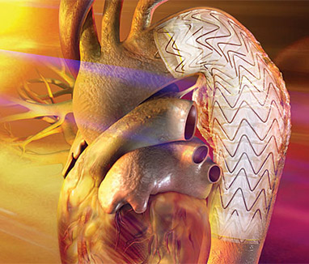 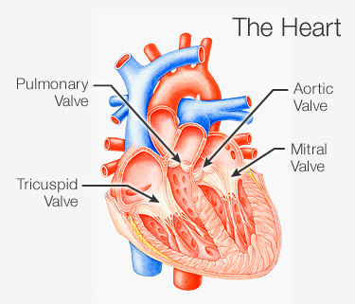

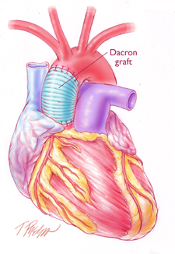

**Patches**

Patches are used to close gaps in the septal wall of the heart . Prosthetic patch has become a widely accept technique for the repair of coarctation .

Patch may be either autogenous or synthetic. Synthetic patches may be made from polyester or teflon mesh or tightly woven polyester .The size of the patch is determined by the length of the arteriotomy , and the patch is made large enough to ensure that sutures can be placed in an area of the heart that is free of disease . patch has been laminated on to the surface of a cardiac pumping diaphragm to maintain a totally biolized surface.

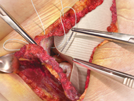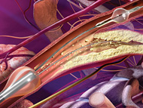

**The vasculature**

The Vasculature consists of arteries , arterioles capillaries and veins . Arteries carry blood away from the heart to all parts of the body, where arteries are made up of layers of smooth muscle fibers and elastic membrane tissue. Arterioles carry blood into capillary tissues . capillaries , the smallest vessels , through which exchange take place between the blood and the tissues, whereas veins carry blood back to the heart

**Vascular grafts**

Vascular grafts have only been a practical reality for about 30 years , surgical techniques and prosthetic technology have been developed rapidly and allowed life and limb saving surgical interventions that many people take for granted , consider that there was no successful surgical for replacement of the aortic aneurysm until synthetic grafts became available. Artificial veins or arteries are used to replace segments of the natural cardiovascular system that are blocked or weakened . Grafts are inserted to bypass the blockages and restore circulation .

**Types of vascular grafts**

Vascular grafts maybe biologic or synthetic. There are three categories of biologic grafts which are autologous grafts ,Allografts and heterografts .Autologous grafts (tissues taken from one part of the body and moved to another part .Allografts or homografts are tissue from one person transplanted into another .

Heterografts are tissues from another species that are transplanted into a human . Synthetic vascular grafts are produced from polyester or polytetraflouroethylene teflon ) with either woven or knitted structures, as parallel, tepered and bifurcated tubes. The grafts normally incorporate a coloured line along the lengh of the graft to assist the surgeon in avoiding introducing twist into the graft as it is implanted.

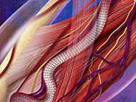 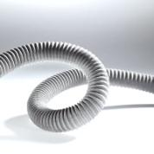

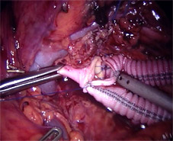

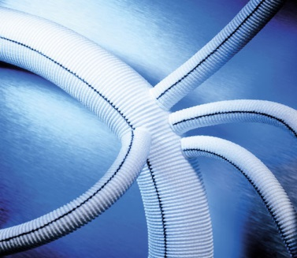 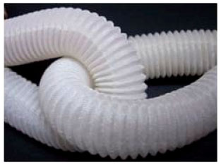

**The ideal graft**

The ideal graft should last a life time and permit blood passage without clotting or infection . The rate should be as close 100% as possible and it should show more compliance . The vessel that is used in replacing.(45) The grafts should be easy to manufacture and store impervious to blood leakage to prevent excessive blood loss and the development of perigraft hematoma , which can interfere with healing and promote infection .(46) Porosity may be essential for fabrics and other biological grafts

**Characteristics of the ideal graft**

Reasonably priced -readily available – variety of size – easy to store easy to manufacture – durable ( survives repeated sterilization , long life in body) suitable for use in the body (bio compatible – non toxic – non allergenic – non throbogenic infection resistant easy to handle ( easy to pass suture needle – pliable elastic – does not kink).

**Requirements for finished vascular graft**

1. porosity, water permeability, integral water permeability, leakage and water entry pressure .
2. strength
3. length
4. relaxed internal diameter
5. pressurized internal diameter
6. wall thickness
7. suture retention strength
8. kink diameter/ radius.

**The cardiac valve prostheses**

The first clinical use of a cardiac - valve prosthese took place in 1952 , when Brcharles Hulngel implanted the first artificial caged ball valve for aortic insufficiency .The first implant of a replacement valve in the anatomic position took place in 1960 since then many different types of heart valve prostheses have been developed and used in general during the past 10 years .

The surgical implantation of prosthetic heart valves has become successful . Today there are many different way making prosthetic valves , because of the various complications , which occur with different valves .

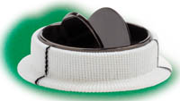 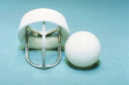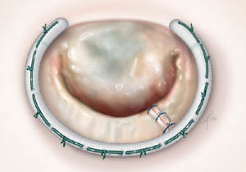

**The ideal heart valve should be**

1. be fully sterile at the time of implantation and be non toxic.
2. be surgically convenient to insert near the normal location of the heart.
3. conform to the heart structure (the size and shape of prosthesis should not interfere with cardiac function.)
4. show a minimum resistance to flow to prevent a significant pressure drop across the valve .
5. have a minimal reverse flow necessary for valve closure , so as to keep the incompetence of the valve allow level .
6. show long resistance to mechanical and structural wear belong – lasting (25 years, ) and maintain its normal functional performance (most not deteriorate over time)
7. cause minimal trauma to blood elements and the endothelial tissue of the cardiac vascular structure surrounding .
8. The valve should also allow probability for thromboembolic complications without the use of anticoagulants .
9. be sufficiently quiet so as not to disturb the patient
10. produce minimal pressure gradient
11. yield relatively small regurgitation
12. minimize production of turbulence
13. not induce regions of high shear stress
14. contain no stagnation or separation regions in its flow field, especially adjacent to the valve super structure .

**Infection in open heart**

Infection in open heart is the most serious complication of heart prosthesis . The signs and systems of infection in open heart which should alert the patient and physician , may first be obvious distal to the graft . The patient may have a sudden loss of peripheral pulses associated with chemical changes of pain . Pallor may also exist, systamic signs and systoms also may result from an infected garft, the patient may have fever ranging from one of a low grade , nature to a very high spikes associated with septicemia and even septic shock . The possibility of the development of an infected graft, particularly when prosthetic material is used as graft must be considered of fever occur, particularly in the absence of anyother obvious source . Other problems may be present such as hemorrhage from the gastrointestinal tract. On the other hand the patient may present with evidence of gross gestrointestinal bleeding

**Requirements of heart prosthesis**

requirements specified for implants with regard to duration of contact with human. Body where the contact medium and the intended biostability of the material are stricter compatibility than those for operating. Theatre textiles and products which are used in direct contact with the central nervous system or in the immediate vicinity of the heart or those which are deliberately dissolved in the body .

The most important general requirement of heart prosthesis is

The compatibility of the material to the human body and the ease with it can be sterilized .

**Biocompatibility requirements**

1. no triggering of immunological reactions and allergies
2. no causing of unusual foreign body reaction
3. no cytotoxic reaction .
4. no mutagenic, teratogenic or earunogenic reaction
5. no undesirable biodegradation
6. blood compatibility – no change in blood composition and blood properties ( blood clothing haemolysis)
7. wide – lumen textile vascular replacement a cement thrombogenic for intraco - operative sealing
8. sterility
9. freedom from pyrogens
10. adequate stability of the structure ( including under long – term loading - tensile- pressure- bending)
11. load- elongation characteristics compatible with the tissue being replaced
12. inter operative length matching of the prosthesis
13. availability in suitable dimensions .