**Health care and hygiene products**

**dr.Ibrahim .g.,e.**

**Protective health care garments**

The purpose of protective health care garments is to protect from contamination by blood and other infection fluids, Protective healthcare textiles include operation and emergency room textiles, barrier products , breath membranes, surgeon and nurse, caps, masks, foot wear , coats.. etcThere are two basic requirements for a protective textile garment, it should be affordable, breathable, comfortable, dependable and effective.The impact of contagious diseases have made hospitals very cautious about protecting fabrics, the medical profession was once concerned mainly with protecting patients from germs, now they must protect them selves. These precautions have caused an increase in demand for medical product stroring. The protective material has to be waterproof but breathable, and it must allow transmission of moisture vapour. They are usually made of polyurethane, polyester or other copolymers. These garments consists of micro porous membranes which provide comfort by allowing body perspiration to be transmitted from the skin surface to the air through a fabric. Health care garments can be woven, knitted or nonwoven. Health care garment could be washable or disposable. Laboratory tests for health care garments include water repellency, lounderability and strength.

**Products used in hospitals**

Products used in hospitals include bedding clothing, shoes covers, cloths incontinence products, cloths and wipes.

**Operating room apparel**

Normal operating room apparel comprises a scrub suit, consisting of trousers and short sleeved tunic, or a dress, this is clean but normally sterile and will normally be worn all day . The traditional material for operating – room apparel is woven cotton dyed in green, in some cases. Woven cotton has the advantages of being easy to launder and sterilize and relatively comfortable to wear, All fabric used for operation room apparel must have antistatic properties .

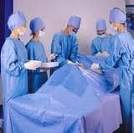 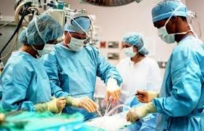 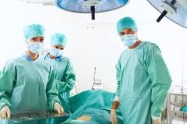

**Nurse’s apparel**

Nurse’s apparel is made of conventional fabrics since no specific requirement is needed other than comfort and durability. These fabrics consist of tissue reinforced with a polyester or polypropylene spun- laid web .

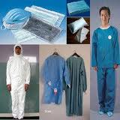 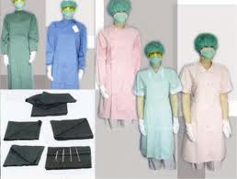

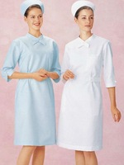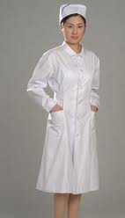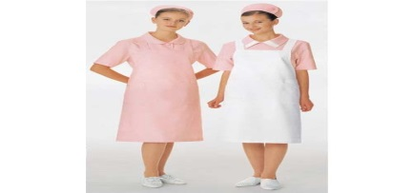

**Surgical mask**

Masks often have a multiple layers structure to ensure more efficient filtration of the breath while masks are made of three layers. The middle layer consists of extra fine glass fibers or synthetic micro fibers covered on both sides by an acrylic bonded parallel-laid or wet-laid nonwoven fabrics. The inner layer consists of a melt – blown polypropylene and outer layer which consists a spun– bonded viscose web to provide strength and to prevent the loss of polypropylene fibers masks also contain tapes which are sewn to enable them to be tied firmly into place over the nose and mouth. . The performance requirements for surgical face masks are high bacterial filtration capacity , high air permeability , light weight and non-allergenic.

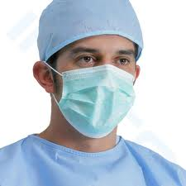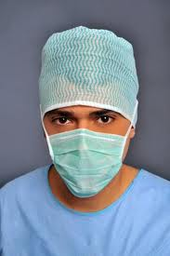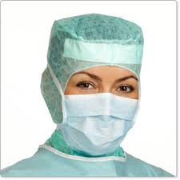

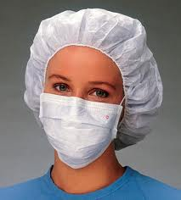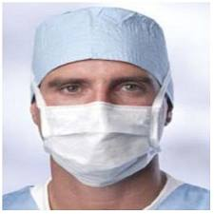 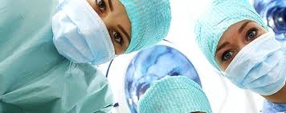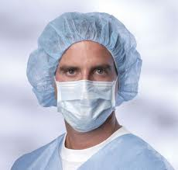

**Surgical caps**

Surgical caps are often made of cellulosic Fibers, with the paralled– laid or spun laid process ,but commonly for surgical spun the surgical cap made in one piece or from two or three pieces sewn to give a better fit

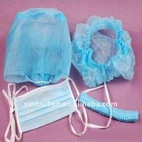  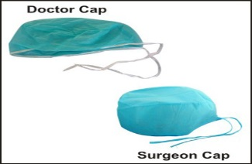 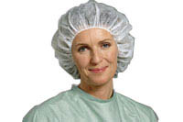

**Overshoes**

Overshoes are usually made in one piece or may by made from two or three pieces sewn together to give better fit. Elastic threads are sewn into the edges of the openings to provide simple efficient closure.

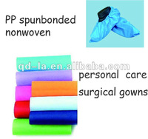 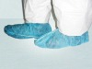 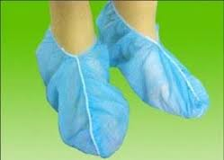

**Gowns**

Gowns manufacturers are responding to higher demands of protection by producing products with increased barrier level. Gowns are often made from polyester cellulose and composite polypropylene fibers , and are supplied in sterile packs and have the additional advantages of being used in the event of major emergency .Woven cotton fabrics are traditionally used in some surgical gowns because cotton does not produce static electrical charges that can build up and produce electric sparks, however it may release particles from the surgeon and also generate high levels of dust , also non woven surgical gowns are used to prevent sources of contamination .

The general requirements for surgical gowns include liquid repellency, bacterial barrier properties, and aesthetics flame resistance static safety and toxicity .

The fabrics should also be sufficiently flexible, adequate strength tear resistance and comfort

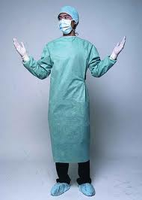

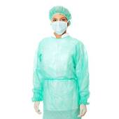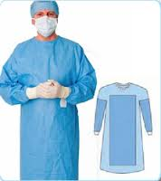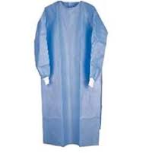

**Surgical Drapes**

Drapes are used in the operating room to cover patients and the area around him to reduce the risk of the wound becoming contaminated by skin cells shed by the patient . Drapes are made from woven cotton or linen, and usually supplied cut to a variety of different shapes appropriate to different surgical procedures and contain an opening according to the position of the surgical site. They could also be made of non- woven fabrics are used as backing material on one or both sides of a film, while the film is impermeable to bacteria. Nonwoven backing is high absorbent to both body perspiration and secretions from the wound. The general requirements for surgical drapes include liquid repellency bacterial barrier, conformability, tactile softness, comfort, strength, fiber tie-down properties lint propensity and abrasion resistance, flame resistance, static safety and toxicity .

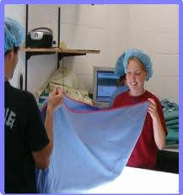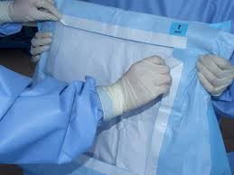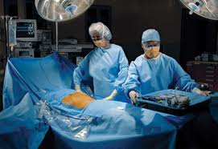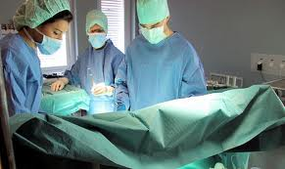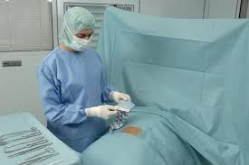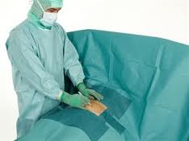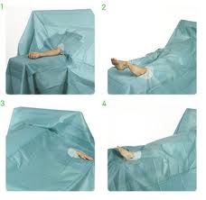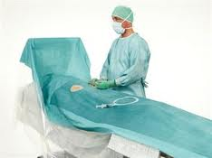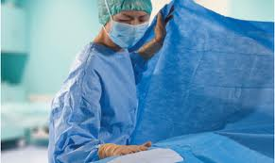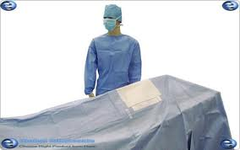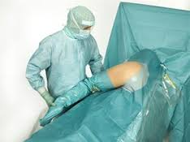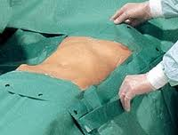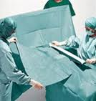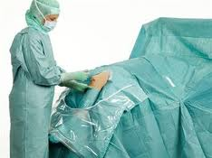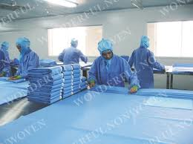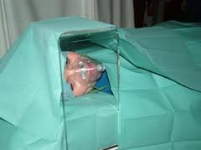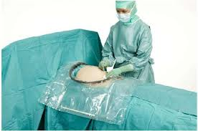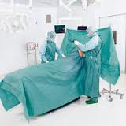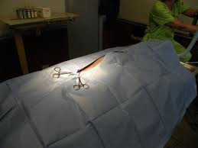

**Bedding**

The bedding is used in the sence of body whose breath is large in comparison with its thickness, the flexible web may be woven or laid down as a nonwoven fabric . It is preferred that the web be permeable to aid the deposition besides that it can allow access of air to the encased limb .The web most preferably has a porous structure and in the case of woven or non- woven fabrics, the porosity of the web may be conditioned by the method of manufacture, so that this particular characteristic may be predetermined to insulate the burned tissues of the patient form it patient for the purpose of covering him to prevent exposure may be required it.

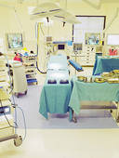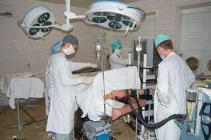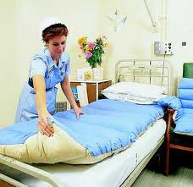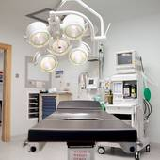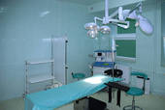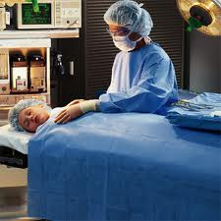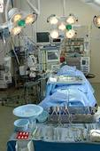

**Wipes and cloths**

Cloths and wipes are used to clean wounds prior to wound dressing or to treat rashes and burns. The wiper is produced by forming a web of nonwoven materials in desired conventional fashion, saturating the web either before or after dying with a liquid solution of the binder material in solvent to cause a pick up by the web of a desired amount of the binder material. The wipe must be capable of retaining .The premoistened wiper which is capable of providing high wet strength until used, the premoistened wiper has a nonwoven web substrate of fibers which are bonded together by polymeric adhesive.

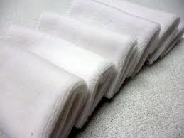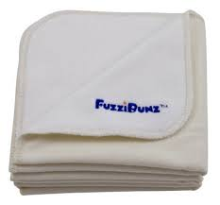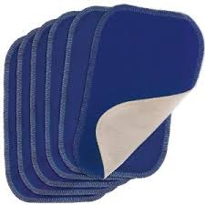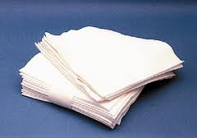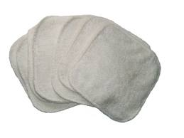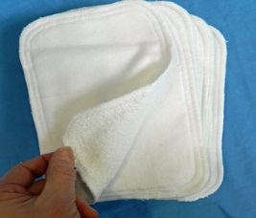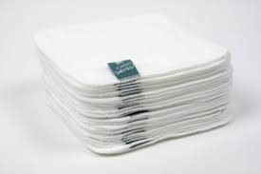

**Surgical swabs**

A swab is an absorbent textile pad used in general surgery to prepare the site of the operation to absorb excess blood and body fluids, to pack body cavities during surgery and to clean the incision prior to suturing .The traditional swab which is made of cotton gauze suffers from disadvantages despite its widespread use. The advantages of traditional swabs, in particular are their high absorbency and non linting properties

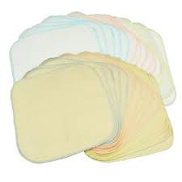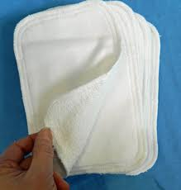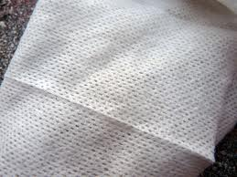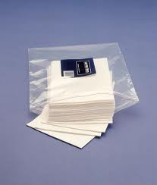 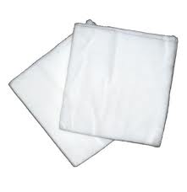

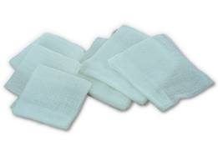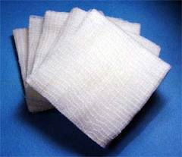- 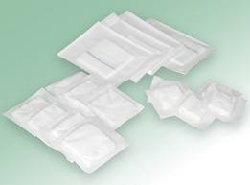 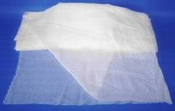

**Lint**

Lint is a plain weave cotton fabric that is frequently used in the treatment of mild burns. Lint consists of 50/50 polyester blended and tightly woven into fabric. It has a durable, moisture resistance and static control finish , it has also proven to be comfortable to wear. Other properties include abrasion resistance, good tensile strength, fast drying and reusability

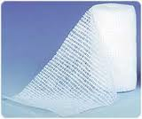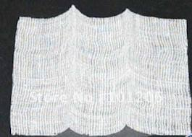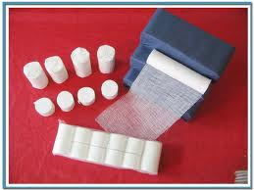

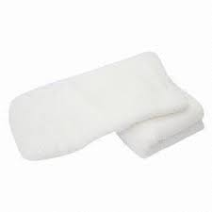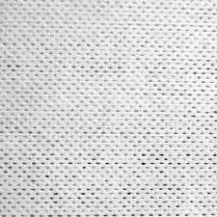-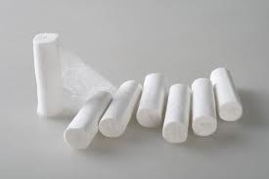

**Surgical towels**

Nonwoven disposable towel have high absorptive capacity and excellent drying ability with minimum of moisture strike- through. Surgeon may have from about 15 to about 30 grams, of water remaining on his hands and arms after the scrubbing operation, this towel has an absorptive capacity of about 4 to about 7grams of water and weights, about 30 grams surgeon’s. The towel is must be demonstrating excellent abrasion resistance, strength, sturdiness and at the same time it must be soft .

**Incontinence and hygiene products**

Incontinence is normally regarded as a problem of the very young , the very old and the disabled or bedridden . There are number of incontinence suffer of all ages , the main problem is that of urinary incontinence with stress (caused by laughing, sneezing extertion or emotional upset ). Product designs need to meet the different levels of incontinence according to different levels of activity from fully active to chair bound or bedridden. Incontinence protection must not leak, or cause discomfort or skin irritation to the patient .

**Nappies (diapers)**

The types of nappies or diapers vary greatly through out the world from reusable cloth to the modern disposable type. ( Disposable diapers and similar have been manufactured using one or more layers of cellulose tissue which makes the diaper relatively stiff . Reusable nappy is made from woven terry cloth which is a woven, warp-pile cotton fabric coverd on both sides with uncut loops . The cloth can vary in thickness and weight according to the thickness and quality of the yarn used and the density of the structure . Reusable nappies need to be changed ,washed and dried.

Reusable napes can be classed into :

**1-One layer diaper**

One-layer diaper has the problem that all the moisture stays evenly distributed through the diaper so that a high amount of urine remains in direct contact with the baby’sskin and can cause diaper rash.

**2-Multi layer diaper**

Multi-layer diaper using 100% cotton for skin contact layer and synthetic nonabsorbent layer of polyester or equivalent to provide a wicking action to draw and hold moisture away from the skin.

**3-A five –layers diaper**

A five layers construction present the deal balance of comfort .The first layer is an interior shell of 100% cotton , The second layer is 100% synthetic nonwoven bonded mono-filament which allows moisture to pass through to the lower layers , the third layer is a 100% cotton wetting pad for maximum additional absorbency with minimum bulk , next is a layer of terry cloth in a cotton/ polyester blend , for extra absorbency . The fifth layer five is also a terry cloth of similar blend to give a panty-like dressed appearance .

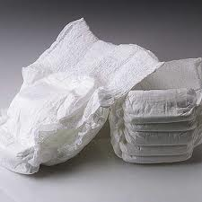 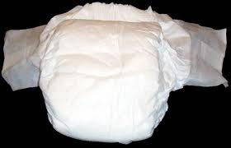 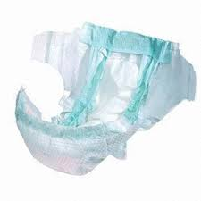 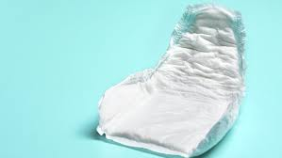

**Sanitary towels**

There are no standard specifications for producing sanitary towels. A small scale reusable sanitary towels tend to consist of a piece of absorbent cotton fabric. Plain woven cotton or terry cloth is appropriate for reusable sanitary towels where a wrapping absorbent cotton wool with gauze are used to form a pad , and a thin, impermeable layers such as polyurethane, is applied to one side of the cotton wool pad, the pad is then wrapped in a piece of gauze or introduced into a thin , open knitted tube and stitched or knotted at both ends and packaged.

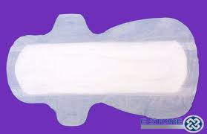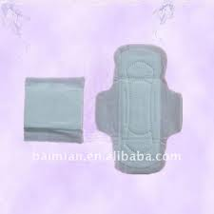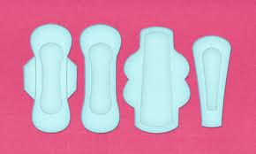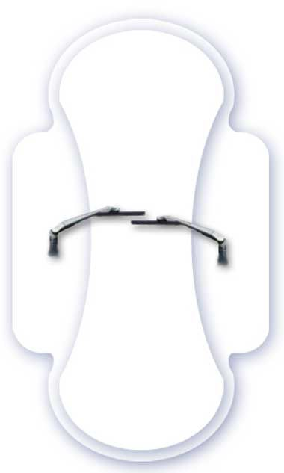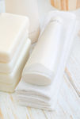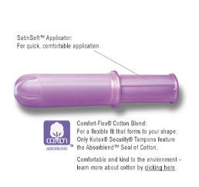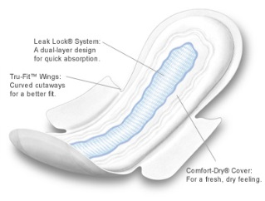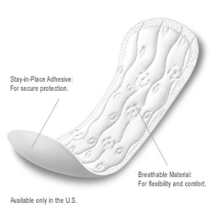

**Anti-thrombosis Stockings (surgical hosiery)**

Surgical hosiery materials possess compression characteristics and are used for various applications , including support to the limb , treatment of venous disorders, protection in physical actives.. etc ,where it estimated that 20% of people suffer from problem associated with veins in their legs which can lead to disorders such as varicose , oedemas and thrombosis . Anti-thrombosis stockings are used as a means of preventing the formation of thrombosis as the compression exerted causes narrowing of the veins in the leg . Anti thrombosis stocking has an almost conical tubular construction–, the innovation anti-thrombosis stocking is that it is now produced in a warp – knitted construction using a double – face- double – bar Rachel machine. Stockings are used when a thrombosis has already formed and they have to be made to suit each patient individually according to the compression needed.

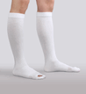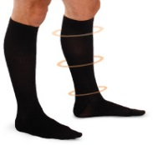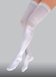T.E.D. Anti-Embolism Stockings, (Thigh Length) Closed Toe 